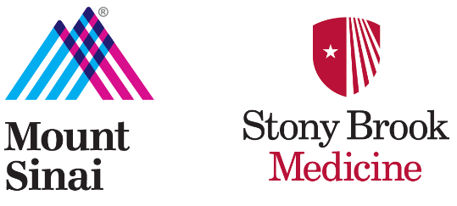

Radiation Therapy
Clinical Non-Credit, Non-Degree Certificate Program Student Handbook
2026 – 2027

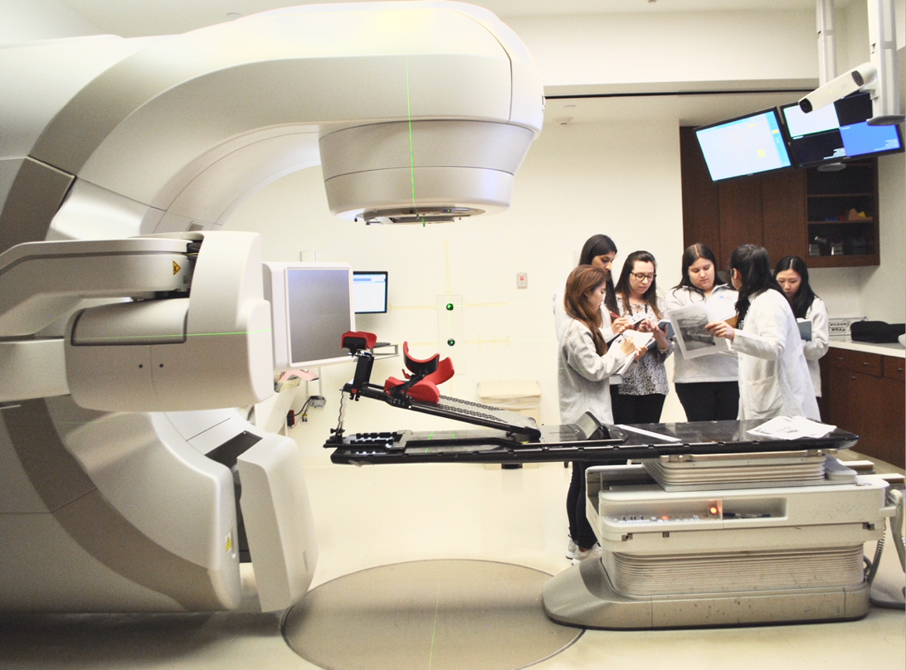

Mount Sinai Center for Radiation Science Education

In collaboration with
The School of Health Profession’s Health Science major

Revised May 18th 2026

Table of Contents
Greetings from the Program Director 4
About the Program 5
About the Mount Sinai Health System 5
Mount Sinai Mission 5
Mount Sinai Vision 5
The Mount Sinai Center for Radiation Sciences Education at Stony Brook University Mission Statement 5
Program Accreditation 5
RTT Program Curriculum: 6
Program Goals & Student Learning Outcomes 7
Clinical Year Faculty & Leadership 7
Clinical Locations & Departmental Supervisors 7
MOUNT SINAI RESOURCES 8
Recreation Office 9
Bookstore 9
Library 9
TUITION/REFUND POLICY 9
CLINICAL EDUCATIONAL HOURS 11
ACADEMIC CALENDAR, ATTENDANCE AND PUNCTUALITY 12
CLINICAL APPEARANCE, DRESS CODE & REQUIRED ACCESSORIES 15
PROFESSIONAL BEHAVIOR 17
GENERAL RULES OF CONDUCT AND SAFETY 18
Conduct 18
Safety 18
Clinical Education: Policies, Procedures & Student Responsibilities 19
Clinical Education Plan 20
Direct Supervision Policy 21
Professional Confidentiality 21
Policy on Disabilities 22
Policy on Monthly Evaluations with Program Director and Clinical Coordinator 22
Academic Integrity 22
Academic Standing, Probation, and Termination Policy 23
Student Appeal Process for Academic Standing Issues 24
Student Grievance Policy and Procedure 24
Critical Incident Management 24
Liability Insurance 24
PREGNANCY POLICY 24
The student may also revoke the declaration of pregnancy at any time and that the revoking of the declaration must be in writing. 25
DECLARATION OF PREGNANCY 25
Subpart B—Radiation Protection Programs 27
Source: 56 FR 23396, May 21, 1991, unless otherwise noted. 27
The MRI Training, Protocol and Screening form can be found in Appendix 11. 27
NEW YORK STATE LICENSURE* 28
CRITERIA FOR PROGRAM COMPLETION 29
Clinical Year Grading System 29
Student Deliverables 29
Guidelines for Clinical Supervisors/Instructors 30
When Filling Out Evaluation Forms 30
CLINICAL BEHAVIOR EVALUATION 30
CLINICAL COMPETENCY POLICY 30
A list of all required competencies can be found in appendix 10. 31
Instructions for Completing Competency Forms 31
SPECIALTY ROTATIONS 31
Physician Specialty - Rotation 32
Brachytherapy Specialty - Rotation 35
Dosimetry Specialty – Rotation 36
OBSERVATIONAL ROTATIONS 36
Proton Observational Rotation 37
COVID-19 POLICY 37
Appendices 38

Greetings from the Program Director

On behalf of the Mount Sinai Center for Radiation Sciences Education at Stony Brook University, I welcome you as our students! We join you in anticipation of a rewarding educational experience at our institution as you prepare for careers as radiation therapists.

We at Mount Sinai are committed to providing compassionate, competent patient care in addition to an exciting and healthy environment for all students in the classroom, and throughout our clinical locations.

The field of radiation oncology is dynamic and incredibly rewarding. We are thrilled to watch you learn and grow under our guidance.

Again, welcome to the team and best wishes for a productive year.



Danielle McDonagh, DHSc., MS, RT(T)
Program Director, Mount Sinai Center for Radiation Sciences Education
Radiation Therapy Program Director, Clinical Assistant Professor, Stony Brook University

About the Program

About the Mount Sinai Health System
The Mount Sinai Health System is an integrated health care system providing exceptional medical care to our local and global communities. Encompassing the Icahn School of Medicine at Mount Sinai and seven hospital campuses in the New York metropolitan area, as well as a large, regional ambulatory footprint, Mount Sinai is acclaimed internationally for its excellence in research, patient care, and education across a range of specialties. The Mount Sinai Health System was created from the combination of The Mount Sinai Medical Center and Continuum Health Partners, which both agreed unanimously to combine the two entities in July 2013.

Mount Sinai Mission
The mission of the Mount Sinai Health System is to provide compassionate patient care with seamless coordination and to advance medicine through unrivaled education, research, and outreach in the many diverse communities we serve.

Mount Sinai Vision
The Mount Sinai Health System’s vision is to continue to grow and challenge convention through our pioneering spirit, scientific advancements, forward-thinking leadership, and collaborative approach to providing exceptional patient care in the many unique communities we serve.

The Mount Sinai Center for Radiation Sciences Education at Stony Brook University Mission Statement
The mission of the Radiation Therapy Program is to optimize the knowledge, attitudes and skills of our students by preparing them to meet the daily challenges of a Radiation Therapist in the dynamic field of Radiation Oncology. Through clinical work and didactic lessons, students will hone the skills that are required to serve our patients in the community while maintaining ethical standards and professionalism in and out of the clinic. They will become an integral part of the health care team in the battle against cancer and leaders in providing the highest level of patient care.

Program Accreditation
The Mount Sinai Center for Radiation Sciences Education at Stony Brook University maintains accreditation through Middle States Commission on Higher Education and has applied for initial accreditation by the Joint Review Committee on Education in Radiologic Technology (JRCERT). The JRCERT is the only agency recognized by the United States Department of Education and the Council on Higher Education Accreditation for the accreditation of traditional and distance delivery educational programs in radiography, radiation therapy, magnetic resonance, and medical dosimetry. The JRCERT awards accreditation to programs demonstrating substantial compliance with the standards found in appendix 16. The Mount Sinai Center for Radiation Sciences Education at Stony Brook University is also a recognized Radiation Therapy Program through the American Registry of Radiologic Technologists (ARRT) and the New York State Department of Health (NYSDOH).

RTT Program Curriculum:

Stony Brook Health Science Major Education:
- Stony Brook Health Science Major Education:
- Human Anatomy and Physiology for Health Science I & II
- Research Methods in Health Science
- Human Anatomy, Health and Medical Language
- Health Care Issues
- Communication Skills
- Professional Ethics
- Health Care Informatics
- Scholarly Writing in Health Science
- Radiation Physics in Medicine
- Principles and Practice of Radiation Therapy
- Radiobiology and Health Physics
- Radiographic Anatomy and Pathology
- Radiation Oncology/Medical Physics II
- Introduction to Pathology

Clinical Year Education:
Orientation to Radiation Therapy (“Clinical Skills Orientation”)
Mini-courses:
- Radiation Oncology
- Simulation
- Clinical Anatomy
- Patient Care
- Clinical Set-Ups
- Professionalism
- Physics/QA
- Communications
- Labs
- Registry Review
Specialty-Rotations:
- Brachytherapy rotation
- Physician rotation
- Dosimetry rotation
- New York Proton Center rotation
Monthly clinical rotations
- 2 months in simulation
- 10 months on treatment units

Program Goals & Student Learning Outcomes

Goal 1: Students will demonstrate clinical competence of an entry-level radiation therapist

Student Learning Outcomes:
- Students will deliver radiation therapy treatments as prescribed by a radiation oncologist
- Students will demonstrate basic knowledge and understanding relative to each site-specific setup

Goal 2: Students will possess critical thinking skills

Student Learning Outcomes:
- Students will adequately respond to challenges faced during treatment setup and delivery
- Students will show the ability to perform multiple tasks in a timely manner

Goal 3: Students will practice with professional values

Student Learning Outcomes:
- Students will display professional conduct
- Students demonstrate life-long learning

Goal 4: Students will display effective communication skills

Student Learning Outcomes:
- Students will demonstrate written communication skills
- Students will demonstrate oral communication skills

Clinical Year Faculty & Leadership
Clinical Year Faculty & Leadership
 | Kenneth Rosenzweig, MD | Mount Sinai Radiation Oncology  Professor and Chair
 | Kimberly Smith, MS | Mount Sinai Radiation Oncology  Vice President
 | Samantha Skubish, MS, RT(R)(T) | Mount Sinai Radiation Oncology  Chief Technical Director
 | Deborah Zelizer, PhD, LCSW | Stony Brook University  SHP Chair  Deborah.zelizer@stonybrook.edu  Office: (631) – 444 - 6158
 | Maria Dimopoulos, PhD, MBA, RT(T) | Mount Sinai Center for Radiation Sciences Education  Associate Director  Radiation Therapy Program Director  Maria.dimopoulos@mountsinai.org  Office: (212) 241 – 5118  Cell: (646) 951 - 7969
 | Danielle McDonagh, DHSc., MS, RT(T) | Mount Sinai Center for Radiation Sciences Education  Program Director: Radiation Therapy Program & Research  Danielle.mcdonagh@mountsinai.org
 | Matias Prando, BS, RT(T) | Mount Sinai Center for Radiation Sciences Education Clinical Coordinator: Radiation Therapy Edu & Research

Clinical Locations & Departmental Supervisors
The RTT program has a meaningful clinical education plan that assures each student is provided with a meaningful and equitable educational experience and that each student can complete all required competencies during their tenure in the RTT clinical non-credit, non-degree certificate program (second year of the program). This is achieved by requiring all students to complete a clinical rotation at each clinical treatment campus where students are exposed to a wide range of treatment techniques and simulations.

All clinical rotations will be conducted at Mount Sinai Health System. The Mount Sinai Health System is one of the largest health systems within the region. As such, the department can provide students with a wide range of procedures to achieve competency requirements put forth by JRCERT. Mount Sinai Radiation Oncology includes 7 clinical treatment locations, in combination there are 15 treatment machines, 6 simulators and brachytherapy offered at each location. Students are to report to the clinical supervisors of each Mount Sinai Radiation Oncology location.

Students gain hands-on learning with various therapeutic and imaging technologies including but not limited to: SRS, SBRT, TBI, CSI, IMRT, 4DCT, Fluro, DIBH, gating, compression, alignrt, exactrac and CBCT. To ensure equity in the educational experience, all students are required to rotate through each treatment location to gain the required clinical experience with all specialty procedures and imaging technology. Additionally, Mount Sinai is a partner in the New York Proton Center. As such, students also complete an observational rotation in proton therapy treatment. A map of all clinical year locations can be found in Appendix 6.

Mount Sinai Hospital
Mount Sinai Hospital – 1184 Building
Address: 1184 5th Ave (1184 Building MC Level), New York, NY 10029
Clinical Supervisor: Kevin Minassain | (212) 241 – 8911 | kevin.minassain@mountsinai.org

Mount Sinai Hospital – Hess Building
Address: 1470 Madison Ave (Hess Building SC Level), New York, NY 10029
Clinical Supervisor: Cynthia Vavasis | (212) 241 – 9498 | Cynthia.vavasis@mountsinai.orgmailto:

Mount Sinai West
Mount Sinai West
Address: 1000 10th Ave (Main elevators to LL), New York, NY 10019
Clinical Supervisor: Natosha Houston | (212)523–6898 | natosha.houston@mountsinai.org

Mount Sinai Downtown
Mount Sinai Downtown - Union Square
Address: 10 Union Square East (SC Level), New York, NY 10003
Clinical Supervisor: Clifford Temple| (212) 844 – 8060 |Clifford.temple@mountsinai.org
Mount Sinai Downtown - The Blavatnik Family – Chelsea Medical Center at Mount Sinai
Address: 325 W 15th Street, New York, NY 10011
Clinical Supervisor: Denise Kraemer | (212) 367 –1796 | denise.kraemer@mountsinai.org

mailto:Mohamed.Radhouani@mountsinai.org
New York Proton Center
New York Proton Center
Address: 225 East 126th Street, New York, NY, 10035
Clinical Preceptor: Andrew Okhuereigbe | (646) 968-9098 |aokhuereigbe@nyproton.com

Mount Sinai South Nassau
Mount Sinai South Nassau Ocean Side & Valley Stream
Address: One Healthy Way, Ocean Side NY 11572
Address: 1 South Central Avenue, Valley Stream, NY 11580
Clinical Preceptor: Rodney Michel | (516) 632-3330 or (516) 632-3326
Rondey.michel@snch.org

MOUNT SINAI RESOURCES

Recreation Office
The Recreation Office offers a wide range of discounts to promote work/life balance and the enjoyment of many of New York City's cultural events. The office provides discounted tickets, promotions, and services that include Broadway and Off-Broadway shows, movies, sporting events, amusement parks, restaurants, health clubs and spas, hotels, cell phone service, car rentals.
All discounts require a valid Mount Sinai Health System ID.
19 East 98 Street, Room 2F
212-241-6660
Recreation.mountsinaihealth.org

Bookstore
At the Posman Collegiate Bookstore, students can order popular books, purchase supplies, food, and gifts. The bookstore is located on the ground floor of the Annenberg Building.

Library
Students have access to the Icahn School of Medicine library at Annenberg 11 with their Mount Sinai student ID. Library hours and details can be found at: https://icahn.mssm.edu/about/ait/levy-library

TUITION/REFUND POLICY

Tuition will be charged at the rate of $8,000 for the clinical year plus applicable university fees (university fees can be found at: www.stonybrook.edu/commcms/sfs/tuition/certificate-program). This annual tuition will be collected by the Program two weeks before program start. The tuition fee shall be made payable to the School of Health Professions. A student shall not be permitted to attend classes or clinical education beyond the posted tuition deadline dates without receipt of tuition and insurance payment or approved payment voucher.

Refund of Tuition:
Students who withdraw from the Radiation Therapy clinical non-credit, non-degree certificate year of the program are liable for payment of tuition in accordance with the following schedule:

Withdrawal during Liability
First week 0%
Second week 30%
Third week 50%
Fourth week 70%
Fifth week 100%

Orientation will be held on the first day of the program. Absence from classes does not constitute an official withdrawal and does not relieve the student of his or her financial obligation, nor entitle the student to a refund. Students must officially request to withdraw, in writing, to the Dean’s Office.

Students will be responsible for other fees incurred during the program. Such fees include but are not limited to:
- Professional liability insurance $39
- Health clearance and toxicology screening as required by clinical sites via Castle Branch $78
- CPR training ~$100

Program Fees, Tuition Costs, and Fraud Prevention
All official tuition and program-related costs are posted through Stony Brook University and should be reviewed directly through the University’s official tuition and fees webpage. Students are responsible for reviewing their tuition, fees, and payment obligations through official Stony Brook University systems and communications.
Students will never be asked by the Radiation Therapy Program Director, education team, Mount Sinai faculty, clinical staff, or program leadership to send money, transfer funds, purchase gift cards, use payment apps, or provide financial information through text message, GroupMe, social media, personal email, or any other informal communication method. Any request for money or funds outside of official Stony Brook University tuition and fee processes should be considered suspicious.
If a student is contacted by anyone claiming to represent the program, Stony Brook University, Mount Sinai, or a member of the education team and is asked to send money or provide financial information, the student must not respond, send payment, or share personal information. The student should immediately contact the Program Director and Stony Brook University using official contact information to verify the request.
Students are expected to complete required cybersecurity training and to use appropriate judgment when responding to electronic communications. This includes verifying the identity of the sender, avoiding engagement with suspicious text messages or emails, not clicking unknown links, and reporting suspected scams promptly.
In the event of a suspected scam or fraudulent financial request, students should:
- Contact the Program Director immediately.
- Report the communication to Stony Brook University and/or Mount Sinai leadership as appropriate.
- Change passwords if there is any concern that accounts or personal information may have been compromised.
- Report suspicious text messages, phone numbers, or financial scams to the appropriate authorities, including ic3.gov when applicable.
The program is committed to maintaining student privacy and safety. Students should also be mindful of the personal information they share publicly or on social media, including clinical location details, schedules, and other identifying information that could potentially be misused by outside individuals. Program-related social media activity will continue to be reviewed carefully to avoid unnecessary disclosure of student location or identifying details.

Health Insurance (required): Students can purchase the university plan or show proof of private insurance.
*Students must uphold health insurance for the duration of the clinical year. Students are not permitted in the clinical environment without health coverage.
Other Program and Professional Estimated Required Expenses*
Textbook | $100.00
Laptop | $750.00
Castle Branch screening and compliance platform - general access** | $43.00
Castle Branch screening and compliance platform – toxicology screening** | $35.00
Professional liability insurance | $43.00
National Professional Society Student Membership (ASRT) | $37.00
BCLS/CPR Training | $100.00
Registration fee for national exam (ARRT exam) | $225.00
NYSSRS/RTANYS Conference | $500.00
Licensure application fee | $120.000
Note: * There will be transportation expenses (vehicle, parking fees, fuel, etc.)

CLINICAL EDUCATIONAL HOURS

Students enrolled in the Radiation Therapy Program must complete a minimum of 235 days (1,645 hours) of supervised clinical education and all clinical evaluations of students must be a minimal pass/satisfactory to qualify for graduation.

- Assignments to all Mount Sinai clinical education centers:

NO STUDENT WILL BE PERMITTED TO ENTER THE CLINICAL SETTING OR ATTEND ORIENTATION WITHOUT A COMPLETED HEALTH FORM AND THE REQUIRED IMMUNIZATIONS AND HEALTH AND LIABILITY INSURANCE.

One-Year Clinical Education Session

- Orientation is mandatory and begins the clinical year.

- Each student will be assigned to a clinical education center five days a week (Monday through Friday) 8 a.m. To 4 p.m. Clinical hours may vary according to site, e.g., 7:00 a.m. – 3:00 p.m. With one-hour lunch breaks at the discretion of the instructor(s) for the duration of the clinical rotation.

- When chart rounds are held at 4pm at MSH students will report to clinic from 9 a.m. to 5 p.m.

- Mini courses will be scheduled throughout the year, most often taking place Wednesday or Friday mornings across Mount Sinai locations. For details regarding mini course date/times, please see the RTT Student Google Calendar.

ACADEMIC CALENDAR, ATTENDANCE AND PUNCTUALITY

The Mount Sinai Center for Radiation Sciences Education at Stony Brook University is a two-year, full-time program that begins during the fall semester of the senior year at Stony Brook University in the Health Science major and continues through a 12-month clinical non-credit, non-degree certificate program at Mount Sinai Health System. The clinical certificate program starts in June and is completed the following June. Clinical certificate program’s didactic mini courses are scheduled by the education team and will be added to the RTT Student Google Calendar. Students are assigned to clinical rotations at various Mount Sinai Health System locations the remainder M-F, 8am-4pm.

The presence of students in the clinical facility must in no way alter the routine work schedule of the department, or inconvenience patients, or staff. Therefore, dependability and punctuality are essential. Students shall not be deemed as employees of Mount Sinai for any purpose, meaning this is an educational experience and as such, students must comply with the policies and procedures put forth in this handbook. Any attempt to alter or falsify an attendance record shall be considered to be unethical and unprofessional conduct and shall be grounds for dismissal from the program.

- Attendance
  - Each student will receive a clinical schedule. Students are allowed in the patient treatment area only on their assigned days.
  - Each student is responsible for signing in and out daily using the Trajecsys system. Students are only permitted to clock in and out while on Mount Sinai campus. Students must be clocked in and at their machines promptly at 8:00 am. Failure to do so will result in lost time.
  - No student will be allowed to have clinical assignments on hospital holidays, weekends, evenings, or nights.
  - Students are not allowed to earn more than 40 hours of clinical time in one week.
  - Only full eight-hour days are given credit, unless previously authorized by the program director.

- Absence & Time Off – Clinical Year:
  - In case of absence due to illness, the student must notify the program director and clinical supervisor by email at least one hour prior to the start of the clinic’s work day.
  - Mount Sinai Radiation Oncology Departments are closed on the following days: New Year’s Day, MLK, President’s Day, Memorial Day, Juneteenth, Independence Day, Labor Day, Thanksgiving, and Christmas. As such, students are excused from clinic.
  - Each student will be entitled to 5 personal days to be used for reasons of religious observance, vacation, minor illness, family needs, etc. Students must email the program director and request the vacation time at least 48 hours prior to the absences due to illness. Vacation requests may be denied given the academic schedule. Students are responsible for notifying their clinical supervisors for the accepted vacation time.
  - Students receive a winter vacation that generally begins on December 24th and extends through New Year’s Day, January 1st. For exact dates please see the RTT Student Google Calendar.
  - An excess of three days absence in any one semester, without prior documentation stating the reason for the absence(s), will be sufficient reason to have the student’s participation in the program reviewed for possible probation.
  - Students will not absent themselves from their clinical schedule for the purpose of studying for examinations.
  - Students may be permitted 2 days of bereavement leave (with appropriate documentation). Students must notify the program director at least 24 hours prior to their absence.
  - Time missed due to inclement weather may need to be made up. This will be at the discretion of the program director.
  - Students should expect that they may be called for jury duty. Because jury duty is a civic responsibility, the Mount Sinai Center for Radiation Sciences Education at Stony Brook University will not ask that students be excused from jury duty. However, if the student’s absence from the program will create a hardship or jeopardize the student's academic work, the student may wish to seek a deferral through the appropriate judicial district.

- Punctuality
  - Each student is required to enter the clinical area at the assigned time.
  - Each student is required to report immediately to their assigned area.
  - A student who enters the clinic late may be sent home at the discretion of the clinical supervisor.
  - Students may not work through lunch hours in order to leave the clinic early, except in extraordinary circumstances. This must be approved by the clinical supervisor and program director.
  - A student who fails to return on time from break or lunch hour may be sent home at the discretion of the clinical supervisor and not be credited with time for that day.
  - A student must contact their clinical supervisor and program director if they expect to be arriving late for ANY reason. They must clock-in accurately and it will be recorded as a lateness.
  - A student with 5 lateness within a semester will be given a WARNING. A subsequent lateness will be grounds for the program director, to recommend to the Dean of SHP in writing, (within five working days) that the student be placed on probation.
  - Students are expected to check email and GroupMe at least once daily to stay abreast of program/clinic updates.

- Make-Up Time
The fulfillment of the minimum required 235 days of supervised clinical education time is the student’s responsibility. Failure to complete the required number of days within the allotted time period may result in a failure to graduate. Therefore, the student is required to make up promptly any days missed.
  - Any necessary absence from the clinic will be made up at the first available time with the approval of the program director.
  - Any time owed, prior to the end of each semester, must be made up prior to credit being given for the start of the following semester.
  - Any time owed must be made up prior to June 28th of the final semester of clinical education

Leave of Absence
- On a case by case basis, the program director may make a recommendation to the Dean of SHP to extend the length of the program for students who need time off for extended illness, family sick leave, or personal leave may be approved to extend their clinical training session no later than June 28th of the final semester.
- To request a leave of absence from the program for personal or medical reasons, students must follow the policies and procedures outlined in the SHP handbook.
- Each student will be assigned to a clinical education session five, eight-hour days per week (9:00 a.m. – 5:00 p.m.) For the remainder of the time necessary to complete the minimum 235 days (1,645 hours) and must accompany satisfactory and timely evaluations of all required clinical and behavioral objectives. Only then, will the student be reviewed to determine if they are qualified to graduate.

CLINICAL APPEARANCE, DRESS CODE & REQUIRED ACCESSORIES

Uniform
- Students must wear Mount Sinai ceil uniform top and pants, embroidered with the Mount Sinai logo (no jeans or shirts acceptable). Students must wear closed toe shoes.

Required Accessories
- A name tag that includes the name of the institution must be worn. It must contain the word “student.”
- Radiation badges must be worn above the waist on same side as name tag.

Personnel Radiation Monitoring:
- Students are to follow Mount Sinai’s Personal Exposure Monitoring Policy (appendix 1). Radiation dosimetry badges are to be monitored monthly by Radiation Safety staff and appropriate follow-up actions taken as may be indicated by the results.
- Dosimeters will be given to students each month. Each student is responsible for exchanging the radiation dosimeter(s) on the designated day of each month. Radiation dosimeters are exchanged with the Program Director.
- Monthly radiation exposures for students must not exceed the maximum permissible dosage to occupationally exposed persons as established by state and federal agencies for radiologic health.
- Radiation exposure reports are posted in each Mount Sinai Radiation Oncology department in a private space and are made available to students immediately following receipt of data, at minimum once per quarter. Student date of birth and/or social security numbers are not included on radiation exposure reports.

Students are responsible for:
- Wearing the dosimeter while on duty in those areas where there is a potential for radiation exposure.
- Exchanging worn dosimeters for new ones on the first workday of each wear period (e.g., first day of month or calendar quarter, depending on assigned wear period), unless the new replacement dosimeters' arrival has been delayed, in which case the exchange may be made as soon as possible after the arrival of the new dosimeters).
- Taking proper care of dosimeters, as described by Office of Radiation Safety instructions, to avoid damaging or contaminating the dosimeters.
- Not storing dosimeters near radiation sources when not being worn.
- Not wearing dosimeters when being exposed to radiation sources for personal medical purposes (The wearer should notify Radiation Safety if this inadvertently occurs or if administered a radiopharmaceutical).
- Notifying Radiation Safety immediately whenever dosimeters are lost, accidentally damaged, name change is required, place of work has changed, or any reason why accidental exposure may have occurred (i.e., dosimeter accidentally left near source when not worn).
- Returning all dosimeters and holders upon termination of duties with/near radiation sources.
- Notifying Radiation Safety/dosimeter distributor of pending student termination.
- Otherwise wear assigned dosimeters in accordance with any other Office of Radiation Safety instructions.
- Failure to comply with guidelines and responsibilities above may result in forfeiture of dosimeters and/or disciplinary action.

Reports to Wearers:
- Dosimeter wearers will be notified of radiation doses as obtained as per the criteria specified in regulations contained in 10 CFR 19 or any other applicable state or federal regulation.
- Individuals may be notified if their cumulative readings in any calendar quarter exceed pre-established ‘investigation levels’, or if any unusual or apparently ‘high’ dosimeter reading(s) are identified by Radiation Safety personnel.
- Regular dose reports [excised of personal information other than dosimeter wearer id number] are provided to the dosimeter distribution group distributor for availability to wearers.
- Individuals may also obtain their dosimeter results by making proper request to the Office of Radiation Safety. Such requests generally are required to be made in writing to protect the individual’s personal information from release to unauthorized personnel.

Regular dose reports are provided to the dosimeter distribution group distributor for availability to wearers and confidential:
- Individual radiation dose readings are considered as protected information and access to this information is limited to Radiation Safety personnel, supervisors, program directors, management personnel, members of the Radiation Safety Committee, regulatory inspectors, or others (with RSO approval) with a legitimate need-to-know.
- Release of individual dose information in any circumstances is limited to the minimum necessary.
- Any other personal information obtained by the Office of Radiation Safety in the administration of the dosimeter program is treated as confidential.

“High” Radiation Dosimeter Readings
- High or unusual radiation dosimeter readings are investigated by Mount Sinai’s Radiation Safety Officer. Readings above designated “Investigation Levels” are evaluated with regard to workload and type of duties performed by the dosimeter wearer; adherence to proper work practices; proper care and use of the dosimeter; and possible exposure of the dosimeter to “non-occupational” radiation sources. In cases where it appears that the high readings may be due to inadequate safe work practices or improper use or storage of the dosimeter(s), the wearer is counseled by Radiation Safety Officer and/or the wearer’s supervisor(s).

Dress Code and Professional Appearance
- Uniform and shoes must be clean and in good repair.
- Hair must be pulled back in a neat fashion.
- Beards and mustaches must be neatly trimmed (religious custom is the only exception).
- Excessive jewelry and excessive use of cosmetics, colognes/perfumes are inappropriate in the clinic.
- Long fingernails and/or chilled nail polish pose a health and hygiene hazard and according to the Mount Sinai Infection Control Policy, are not tolerated.
- Careful attention must be paid to personal hygiene when attending clinic.
- Radiation therapy students on certain occasions will be required to wear business attire during clinical internships.
  - In this even all students must wear closed-toe shoes and no sneakers
  - Jeans are not permitted clothing must cover the shoulders and midriff.
- Failure to dress properly may result in being sent home at the discretion of the clinical supervisor or program director. No clinic hours will be credited.

PROFESSIONAL BEHAVIOR

- Performance Skills and Attitudes – Assessment Procedures

In addition to mastery of cognitive skills and knowledge, students will be evaluated on their performance skills and attitudes. These include the following:

  - Adherence to Stony Brook University’s Code of Conduct;
  - Adherence to the SHP policies and procedure manual;
  - Adherence to the Mount Sinai Health System policies and procedures;
  - Ability to work with and relate to peers, faculty, and other members of the health care team;
  - Maintain a positive and respectful attitude in all aspects of work;
  - Maintain attendance and arrive on time to work; and
  - Conduct oneself in a professional demeanor at all times, including professional dress.

Successful completion of each rotation requires that the student continuously maintain high standards. This means that regardless of one’s level of achievement in cognitive skills and knowledge, if one’s professional behavior is not appropriate, they may not meet minimum requirements for successful completion of the rotation.

- Unsatisfactory Performance Skills or Attitudes

Unsatisfactory behavior such as disruption of class activities, expression of derogatory, disrespectful remarks to the instructor, inability to work with peers, or excessive unexcused absences will result in further action.

A student who has exhibited unsatisfactory behavior that may affect their final evaluation and academic standing shall receive a warning that stated behavior may jeopardize successful completion and lead to disciplinary action.

The details of these policies and procedures can be found in the Academic Standing Policy of the School of Health Professions; see the SHP Handbook for Certificate Programs at:
Https://healthtechnology.stonybrookmedicine.edu/students/incoming/orientation

All students are also expected to adhere to the Stony Brook University Student Conduct Code (available on the SHP webpage).

GENERAL RULES OF CONDUCT AND SAFETY

Students are expected to conduct themselves in a professional manner at all times, reflecting the integrity and values of the Mount Sinai Health System. Failure to comply with the rules of conduct and safety will result in disciplinary action.

Conduct
- Students are expected to observe guidelines set forth in the directives (article 35) issued by the New York State Department of Health, Radiologic Technology, Bureau of Environmental Radiation Protection.
- Students must abide by the policy and standard rules and regulations of the SHP, Radiation Therapy Program, and the Mount Sinai Health System.
- Students will address the staff, patients, and fellow students by their appropriate title and/or last name.
- Smoking, eating, and drinking are permitted in designated areas only.
- Personal relationships with staff and patients are prohibited.
- Personal conversation and discussions with classmates or staff while interacting with patients are in poor taste and should be limited to off-duty hours.
- Grievances should follow the Stony Brook SHP Handbook.
- Cell phone use is not permitted during clinic hours and should be stored in student lockers. Cell phones are not to be on the person of any student in clinic areas.

Safety
- Students are required to acquaint themselves with the routine radiation and electrical safety policies and procedures and abide by all departmental radiation safety rules.
- Accidents involving patients will be reported immediately to the program director and clinical supervisor who will file a written incident report.
- Accidents involving students will be reported immediately to the program director and clinical supervisor who will file a written incident report. The student will then report to the Mount Sinai Emergency Department to be evaluated and cleared.
- Radiation dosimetry (film) badges will be worn at all times while in the clinical facility and left within the facility upon leaving for the day. Film badges are not to be taken home. Film badges are not permitted to travel between clinical sites
- Gross and willful negligence in the use of radiation and/or in the handling of radioactive substances which endangers the health of the student(s), staff, or patients, will result in an immediate removal from the clinical rotation and a recommendation for immediate dismissal from the program.

Clinical classroom etiquette is as follows:
When not occupied for a mini course, the Mount Sinai Hospital Classroom and the Mount Sinai West Classroom are the personal workspaces of the Center for Radiation Sciences Education leadership team. As such, students should respect the space as follows:
- The primary desk and computer are not to be used by students; at no time are students permitted to eat or work at educators’ desks.
- When a member of the education leadership team is working from a classroom, it is not to be a shared space for students to break for lunch or work on their assignments. The cafeteria and library allow ample space for students to eat and study.
- Students must ensure the space is tidy after using the classrooms for mini courses.
- At no time may students eat in either the MSH or West classroom.
- Failure to abide by clinical classroom etiquette will result in disciplinary action.

Clinical Education: Policies, Procedures & Student Responsibilities
The application of theory learned in the classroom is applied to the clinical environment throughout the student’s clinical education.

The following procedures are to be utilized when a student attempts to satisfy all Performance Objectives:

The clinical instructor(s) maintains all ongoing processes where the student must:
- Observe the Instructor perform the specific procedure.
- The student will assist the instructor perform the specific procedure.
- Have the Instructor observe the student enact the same procedure.
- Have the Instructor critique and correct any possible errors.
- Prior to the student’s attempt to satisfy a specific performance objective, the student must successfully perform the procedure previously.
- Having satisfied the above criteria, the student can request (at their own discretion), that the instructor evaluates their performance for Clinical Competency.
- The student must perform each step of the procedure correctly and consistently to be deemed successful in satisfying any attempted objective.
- In line with JRCERT standards. The Mount Sinai Center for Radiation Sciences Education permits only one student—either medical dosimetry or radiation therapy—to shadow on each treatment machine or simulator at a time. The student to machine ratio is 1:1

Clinical competency evaluation forms are maintained to record student grades and progress and to communicate their performance. All records are maintained electronically via Trajecsys and verified by the Program Director. A student not successful in completing their clinical requirements will be ineligible for graduation. The program uses the Monthly Clinical Performance Evaluation form, Clinical Competency Evaluation, and Procedure Log to document and evaluate student progress during the clinical practicum.

All educational activities of the Program are maintained with various channels of communications. Methods of communication include but are not limited to: scheduled clinical site visits by the Program Director, intermittent telephone calls, written correspondence, advisory committee meetings, and formal and informal conversations with the Clinical Supervisors and formal student/program director meetings.

Each student is provided with a Clinical Education Handbook during the required Orientation to Clinical Education session on the first day of the clinical practicum. Due process policies for students participating in the clinical education component are in place, as are the behavioral and technical objectives and standards, attendance academic standing, probation and dismissal, and pregnancy policies. Each student is responsible for following and for reminding clinical staff of all policies and procedures.

Clinical Education Plan
Monthly clinical rotation schedules will be provided to each student and the clinical supervisors during orientation.

At the start of each monthly clinical rotation, the clinical supervisor will introduce the department on the first day of a student’s clinical assignment. Students will be oriented to the hospital and the department. Students will present a “Monthly Student Intake Form” (appendix 2) on the first day of each monthly clinical rotation. This document will review student experience, goals, objectives, and expectations.

The “Plan” for the clinical education component of this program is to satisfactorily complete all clinical competencies and required assignments. All clinical courses will have competency objectives incorporated into an evaluation instrument.

Students are evaluated by the clinical staff at the end of each month. These evaluations will be utilized to establish a final grade (Pass/Fail) for the clinical education session and are kept in the student’s file. The first two months of the clinical year, students will be evaluated using the “Monthly Student Evaluation – Level I” form (appendix 3), and “Monthly Student Evaluation – Level II” (appendix 4) all months thereafter.

Specialty rotations in brachytherapy, dosimetry, proton therapy and with a physician will be assigned in the spring semester.

Instructional methods used to teach all clinical coursework include: Demonstrations, Personal Experiences, Case Study, Lecture, Labs and Simulation Techniques.

Following successful completion of the clinical year, students receive a Clinical Completion Record inclusive of the following:
- 235 days of clinical education in accordance with the Time & Attendance Policy
- Clinical competency requirements and satisfactory clinical performance evaluations for clinical rotations
- Study Units with the minimum passing grade of 75%
- The clinical year will appear on the graduates' Stony Brook University official transcript as an "S" for Satisfactory/Pass. The graduate completed the program on the date listed above

235 Clinical education days Complete
Clinical competency requirements Complete
Clinical performance evaluations Satisfactory
Study units
Exams 30% _____
Assignments 10% _____
Papers & presentations 20% _____
QA 10% _____
Logs 10% _____
Monthly clinical evaluations 20% _____

Final clinical non-credit, non-degree certificate program grade: _____
Final transcript grade documented as Pass/Fail: Pass/Satisfactory

Direct Supervision Policy
All clinical activities involving a patient shall require appropriate supervision by a registered radiation therapist or any appropriate clinical staff member, e.g. RN, CMD, MD, etc. as follows:
- Students must never begin to prepare a patient for treatment or simulation without the clinical supervisor or a designated registered technologist being present in the treatment room or the simulation room.
- Students may bring patients into a treatment room, simulation suite, exam room etc. But may NOT begin to prepare the patient for any procedure without direct supervision
- Direct supervision requires that the technologist, nurse, oncologist etc. Is in the room with the student and is directly available
- Students are not permitted to activate the radiation beam or the CT scanner without the clinical supervisor or a designated registered technologist present, having given a verbal confirmation prior to each beam delivery in adherence with Mount Sinai departmental policy RO.2.12 (appendix 5).

Professional Confidentiality
One of the major restrictions that a health care profession imposes is the need to maintain strict confidentiality of medical and personal information about a patient. Medical records are comprised of many parts including the following: histories, diagnostic images, and radiographic film records. They must be handled confidentially and cannot be revealed to the patient, family, or others outside the department without the direct consent of the patient’s physician. Medical information should only be shared with individuals who are involved in the patient’s care and must know this information for treatment purposes. Information should never be discussed with the student’s family or friends even in the most general terms, as this would be violating the patient’s rights.

An invasion of privacy can be as obvious as releasing medical information to the press, or as subtle as discussing a patient’s condition with a co-worker in a public place. Students must maintain confidentiality and ensure the privacy of each patient.
Students must maintain strict confidentiality of all health information of patients at Mount Sinai sites during and after the course of their clinical rotations. Students may neither use nor disclose health information of patients to which they have access, other than as expressly authorized by the clinical affiliate. Students may not record any patient-identifiable information on their personal documents (e.g. Clinical logs). Students must be familiar with and adhere to Mount Sinai’s HIPAA policy.

Policy on Disabilities
Student Accessibility Support Center (SASC):
If you have a physical, psychological, medical, or learning disability that may impact your course work, please contact Student Accessibility Support Center, ECC (Educational Communications Center) Building, Room 128, (631) 632-6748. They will determine with you what accommodations, if any, are necessary and appropriate. All information and documentation are confidential. Students who require assistance during emergency evacuation are encouraged to discuss their needs with their professors and Student Accessibility Support Center. For procedures and information go to the following website: http://www.stonybrook.edu/ehs/fire/disabilities

Policy on Monthly Evaluations with Program Director and Clinical Coordinator
Each student will meet with the program director and clinical coordinator within 1 week following the end of each month. The students will be prepared to show and discuss the following:
- Monthly attendance sheet (daily clinic, quality assurance)
- Monthly evaluation sheet
- Record of involved procedures
- Record of competency form

Academic Integrity
Each student must pursue their academic goals honestly and be personally accountable for all submitted work. Representing another person's work as your own is always wrong. Faculty is required to report any suspected instances of academic dishonesty to the Academic Judiciary. Faculty in the Health Sciences Center (School of Health Professions, Nursing, Social Welfare, Dental Medicine) and School of Medicine are required to follow their school-specific procedures. For more comprehensive information on academic integrity, including categories of academic dishonesty please refer to the academic judiciary website at http://www.stonybrook.edu/commcms/academic_integrity/index.html

Academic Standing, Probation, and Termination Policy
Students must achieve a minimum 75% (equals “C”/pass) in all of the following non-credit didactic courses to qualify for graduation: Clinical Radiation Oncology, Simulation, Clinical Set Ups, Professionalism, Patient Care, Radiation Protection and Physics.

Student escalation follows the SHP policies and procedures regarding probation and termination contained in this book.

Following two warnings, the program director will recommend to the dean in writing, (within five working days) that the student be placed on probation following performance or behavior that requires disciplinary action. A recommendation for probation may also follow any egregious violation of the student policy. Disciplinary action is indicated by the following:
- A student who has been placed on probation may not ordinarily be permitted to participate in full-time clinical practice, except under extraordinary circumstances, and at the discretion of the program faculty and the dean.
- A student enrolled in the program will receive a warning if they receive a grade of less than 75% (equals minimum passing grade of “C”) on any required didactic course within the program’s curriculum.
- A student that does not complete 3 competencies successfully per month, or who fails a competency attempt 3 times will be given a warning.
- A student that fails 11 competencies throughout the course of the clinical year will be placed on probation.
- A student who does not complete 1 chart round and 1 early QA shift per monthly clinical rotation will be given a warning. Any second warning will result in probation.
- A student that receives under a 3.0 monthly evaluation will receive a warning. A second evaluation under 3.0 will be escalated for a recommendation to probation.
- A student who logs patient learning logs less than 3 times per week will be given a warning.
- A student given a warning or placed on probation will undergo remediation with the program director and relative clinical supervisors.
- Unsatisfactory, disrespectful and/or unethical clinical performance alone will result in a recommendation to the dean for probationary status and/or possible termination from the program.
  - Not adhering to program/institution policies and general rules of conduct and safety will result in disciplinary action
- Any student will be recommended for termination from the Radiation Therapy Program if, while on probation, their academic grade(s) falls below 75% and/or a grade of unsatisfactory in any clinical education evaluation(s).
- Students who fail (less than 75% or “C”) two (2) required courses in one (1) semester will be recommended by memo to the dean, for termination from the program.
- A student who receives both a didactic course grade of less than 75% and one or more unsatisfactory clinical evaluations will be recommended, by memo, to the dean for termination from the program.
- A student placed on probation twice will be recommended for termination from the Radiation Therapy Program.

If the requirements of ethical behavior, respectful behavior, health, good academic and clinical standings are not met, the student may be placed on probation or dismissal from the program.

Student Appeal Process for Academic Standing Issues
See the Stony Brook University SHP Student Handbook for the student appeal policy and procedure. This policy can be found on page 9, section G:
Https://healthtechnology.stonybrookmedicine.edu/sites/default/files/2021%20SHP%20Student%20Handbook%20for%20Certificate%20Programs.pdf

Student Grievance Policy and Procedure
See the Stony Brook University SHP Student Handbook for the Academic Grievances Policy.

Critical Incident Management
Stony Brook University and the Mount Sinai Health System expect students to respect the rights, privileges, and property of other people. Faculty are required to report to the Office of University Community Standards any disruptive behavior that interrupts their ability to teach, compromises the safety of the learning environment, or inhibits students' ability to learn. Faculty in the HSC Schools and the School of Medicine are required to follow their school-specific procedures. Further information about most academic matters can be found in the Undergraduate Bulletin, the Undergraduate Class Schedule, and the Faculty-Employee Handbook.

Liability Insurance
Students are required to provide proof of professional liability insurance coverage. A policy can be purchased from CM&F Group. Students are required to carry a minimum of $1,000,000 policy coverage. The annual policy coverage should begin on the first day of clinical rotations. Approximate cost is $39.00/year. The policy cover page, including dates of coverage and coverage amount needs to be submitted to the program director. Students are not permitted access to the clinical areas without documented proof of liability coverage.
Https://www.cmfgroup.com/professional-liability-insurance/radiation-therapist-insurance/

PREGNANCY POLICY
The pregnancy policy of the Stony Brook University Radiation Therapy Program is designed to reduce the potential for radiation exposure to the fetus and to assure that the student participates in an academic and clinical curriculum that will enable the student to meet the objectives of the program.
In the event that a student becomes pregnant while enrolled in the program, the individual has the option of whether or not to inform the Program Director of the pregnancy. If the student chooses to inform the Program Director, it must be in writing. In the absence of this voluntary, written disclosure, a student cannot be considered pregnant. Upon receipt of a written, voluntary disclosure of pregnancy, the student shall be given a choice of three (3) options, as follows:
- To continue full participation in the program modified by program officials to exclude or postpone assignments and/or employ additional safety precautions for those procedures that carry greater potential for occupational radiation exposure.
- To continue full participation in the program without modification or interruption.
- To withdraw completely from clinical training.
If a student chooses to discontinue clinical education, the student will be permitted to complete the didactic portion of the curriculum. The student will be required to be in attendance only during scheduled classroom hours as is possible. The remaining clinical training hours and all clinical competencies shall be completed at a time mutually agreed upon following the course of pregnancy. The student shall be eligible for certification and licensure only upon satisfaction of all program graduation criteria.
If a student chooses to continue with Clinical Education:
- The program officials shall determine the exact form and content of the plan for clinical training should modification be selected by the student.
- A fetal exposure monitor will be issued, and possibly additional shielding materials made available if necessary.
- The plan must not compromise the program objectives or the education of the other class members.
- Efforts shall be made to allow the student to continue in the program as long as medically advisable and educationally valid.
- The student shall meet with the Radiation Safety Officer to be advised of the most current information available regarding possible medical risks of radiation exposure to the fetus and the radiation exposure monitoring guidelines to be followed.
- The student must adhere to the pregnancy policy of the clinical education center to which assigned.

The student may also revoke the declaration of pregnancy at any time and that the revoking of the declaration must be in writing.

DECLARATION OF PREGNANCY

I, ___________________________, do hereby make this voluntary declaration of pregnancy. My estimated date of conception was ________________, 20___.

It has been explained to me that I am making this voluntary declaration of pregnancy. I understand this means the Radiation Therapy Technology Program/Licensee must take measures to ensure that the total dose to the embryo/fetus during the entire pregnancy from occupational exposure does not exceed 0.5 rem (5 msv). If, as of this date, the total dose to the embryo/fetus is 0.45 rem (4.5 msv) or greater, the total dose to the embryo/fetus during the remainder of the pregnancy shall not exceed 0.05 rem (0.5 msv).

It has been explained to me that these measures may include the reassignment of clinical rotations and corresponding learning objectives to those that will result in lower occupational exposure or the placement of certain restrictions on the duties that I perform.

It has also been explained to me that I may revoke the declaration of pregnancy at any time and that the revoking of the declaration must be in writing.

______________________ _______________
(Student) Radiation Therapist Date

______________________ _______________
Radiation Safety Officer Date

***Sample Document***
(Not to be used as an official form)

Subpart B—Radiation Protection Programs

Source: 56 FR 23396, May 21, 1991, unless otherwise noted.

§20.1101 Radiation Protection Programs
- Each licensee shall develop, document, and implement a radiation protection program commensurate with the scope and extent of licensed activities and sufficient to ensure compliance with the provisions of this part. (See §20.2102 for recordkeeping requirements relating to these programs.)
- The licensee shall use, to the extent practicable, procedures and engineering controls based upon sound radiation protection principles to achieve occupational doses and doses to members of the public that are as low as is reasonably achievable (ALARA).
- The licensee shall periodically (at least manually) review the radiation protection program content and implementation.
- To implement the ALARA requirements of §20.1101 (b), and notwithstanding the requirements in §20.1301 of this part, a constraint on air emissions of radioactive material to the environment, excluding Radon-222 and its daughters, shall be established by licensees other than those subject to §50.34a, such that the individual member of the public likely to receive the highest dose will not be expected to receive a total effective dose equivalent in excess of 10 mrem (0.1 msv) per year from these emissions. If a licensee subject to this requirement exceeds this dose constraint, the licensee shall report the exceedance as provided in §20.2203 and promptly take appropriate corrective action to assure against reoccurrence.

[56 FR 23396, May 21, 1991, as amended at 61 FR 65127, Dec. 10, 1996]

§20.1208 Dose to an embryo/fetus
- The licensee shall ensure that the dose to an embryo/fetus during the entire pregnancy, due to occupational exposure of a declared pregnant woman, does not exceed 0.5 rem (5 msv). (For recordkeeping requirements, see §20.2106.)
- The licensee shall make efforts to avoid substantial variation above a uniform monthly exposure rate to a declared pregnant woman so as to satisfy the limit in paragraph (a) of this section.
- The dose to an embryo/fetus shall be taken as the sum of—
  - The deep-dose equivalent to the declared pregnant woman; and
  - The dose to the embryo/fetus from radionuclides in the embryo/fetus and radionuclides in the declared pregnant woman.
- If the dose to the embryo/fetus is found to have exceeded 0.5 rem (5 msv), or is within 0.05 rem (0.5 msv) of this dose, by the time the woman declares the pregnancy to the licensee, the licensee shall be deemed to be in compliance with paragraph (a) of this section if the additional dose to the embryo/fetus does not exceed 0.05 rem (0.5 msv) during the remainder of the pregnancy.

The MRI Training, Protocol and Screening form can be found in Appendix 11.

NEW YORK STATE LICENSURE*
The student, after the successful completion of this two-year course of study, will be eligible to make application for New York State licensure. Two-year course of study is defined by successful completion of the Health Science major (with the applicable concentration of study) and the successful completion of the clinical non-credit, non-degree certificate program. To be employed as a radiation therapist in the State of New York the graduate must possess both the State of New York Department of Health license and pass the certification examination of the American Registry of Radiologic Technologists in Radiation Therapy. Graduates shall be issued a temporary permit to practice Radiation Therapy upon graduation, if the following criteria have been met:

- Application for licensure has been submitted to and accepted by the New York State Department of Health.
- The NYS Department of Health further requires that:
Except for minor traffic violations, individuals who have ever been convicted for any offense against the law or are now under charges are required to contact the New York State Department of Health, Telephone # (518) 402-7580.
- Application has been submitted and accepted for the examination in Radiation Therapy of the American Registry of Radiologic Technologists.

Upon successfully completing the registry examination, the graduate is eligible for professional licensure by the State of New York. An application fee must be submitted with each application.

* Subsequent to passing the examination and upon program director verification of program completion, the student may obtain the requisite New York State, Department of Health license to work as a radiation therapist. Since the program will operate under the University’s accreditation as an approved New York State program, students completing this program of study would not be eligible for licensing in New Jersey. New Jersey only has reciprocity with professional accredited, Joint Review Committee on Education in Radiologic Technology (JRCERT), programs.

CRITERIA FOR PROGRAM COMPLETION
In order to successfully complete the clinical program in Radiation Therapy and to be eligible to receive a Certificate of Completion, each student must satisfy the following criteria:

1. Complete 235 days of clinical education in accordance with the Time & Attendance Policy

2. Complete Clinical Competency requirements and receive satisfactory Clinical performance evaluations for each assigned clinical rotation.

3. Complete each Study Unit with the minimum passing grade of 75%

Clinical Year Grading System
Student’s final clinical grade will be calculated based on the following courses, evaluations, and deliverables:
- Didactic coursework (exams, assignments)
- Log completion
- Grand round deliverables
- Quality assurance attendance
- Monthly clinical evaluations
- Mini – rotation deliverables
- Journal Club Presentations

Students will receive numerical grades throughout the clinical experience; however, SBU transcript grades will be documented as Pass/Fail.

Student Deliverables
In addition to completing treatment competencies, effective during month 3 (August), students are to complete the following activities and submit deliverables as required in the learning management system at the respective date and time:
- 1 quality assurance attendance per month to be entered in Trajecsys (Appendix 7)
- Grand rounds once per quarter
  - Deliverable: Essay on key take-aways (Appendix 8)
- Journal Club presentation once per quarter
  - Deliverable: Presentation on key take-aways (Appendix 9)
- Log submission, three submissions/week, to be entered in Trajecsys

- All deliverables must be submitted on time. Late assignments will be deducted 5 points per day.

Students are not permitted to work on program deliverables while in clinic. Doing so will result in disciplinary action.

Grade Numerical Equivalent
A 95-100
A- 90-94
B+ 88-89
B 85-87
B- 80-84
C+ 78-79
C 75-77 *Passing grade for the program is 75
C- 70-74
F <70

Guidelines for Clinical Supervisors/Instructors

When Filling Out Evaluation Forms

Evaluation forms are designed to evaluate either the cognitive, psychomotor, and/or effective skills of students. When evaluation forms are being filled out, the ratings and comments should address the competency and skills that can be expected of a radiation therapist student, not an experienced radiation therapist.

Please refer to the following where applicable:

Cognitive Skills: Deal with the application of knowledge and the development of
Intellectual abilities.

Psychomotor Skills: Deal with behavioral tasks involving physical action.

Affective Skills: Deal with interest, attitudes, and value.

CLINICAL BEHAVIOR EVALUATION

The monthly student evaluation form (appendix 3 and appendix 4) must be completed via Trajecsys by clinical supervisors, including appropriate (online) signatures, each month. Students are to be evaluated using the “level I” form the first two months of the clinical year (June, July), and using the “level II” form the remainder of the clinical year (August – May). Both evaluation forms include objectives for clinical, behavioral and performance skills. Clinical supervisors work with the radiation therapy team assigned to the student for the month when completing monthly evaluation forms in Trajecsys.

Instructors/Evaluators are encouraged to elaborate upon the student’s strengths and/or areas that need improvement based upon the content of this evaluation and overall student/instructor/patient interactions in the comments section. Evaluators are requested to address any “no” answer(s) in the evaluation.

CLINICAL COMPETENCY POLICY

Starting the third month of the clinical year (August) a minimum of 3 simulation or treatment competencies are due by the last day of each month. All competencies must be completed prior by the end of the evaluation period in order to ensure a timely grade.
- 1 competency to be selected and assessed by the clinical coordinator or program director
- 1 competency to be selected and assessed by the clinical supervisor
- 1 competency to be selected by the student, and assessed by either the program director, clinical supervisor, or clinical preceptor.

A list of all required competencies can be found in appendix 10.

Instructions for Completing Competency Forms
Evaluations will not be considered complete unless all the information requested on the form in the student section is filled out entirely. The student must have observed, participated in, and performed the set-up independently at least once before requesting evaluation of performance by the supervising instructor.

The student must present the treatment and setup to the clinical preceptor prior to walking the patient in for identification. The student must explain the competency details to the clinical preceptor at the beginning of each competency. During this presentation, the student must explain the site, dose, diagnosis, histology, imaging and any other relevant information.

The supervising instructor must check off the appropriate areas on the Competency Form as each task is correctly performed (appendix 11 and appendix 12).

If a student commits an error while attempting the patient set-up, the evaluation process is terminated at that point. The error is then indicated on the worksheet and entered into Trajecsys. The sheet that reflects the error must be kept on file and the student must repeat the process from the beginning.

All completed Competency Forms will be kept in the student’s folder and submitted to the program director, along with the other evaluation forms, by the last clinical day of the clinical month rotation.

Please note: students will be evaluated for specialty rotations (dosimetry, physician and brachytherapy), through submitted essay, reflective journal and worksheet.

SPECIALTY ROTATIONS

Specialty rotations include 1-week internships to better understand departmental function, and patient experience in Radiation Oncology. Students will spend 1 week under a physician’s supervision and service to understand patient consults, on treatment visits and follow-ups, nursing education, as well as the communication between the department and patient. Students will spend 1 week in dosimetry, reviewing hand calculations, gaps, and crafting treatment plans under the supervision of a Mount Sinai dosimetrist. While rotating to the Blavatnik Family – Chelsea Medical Center at Mount Sinai, students will shadow brachytherapy procedures alongside radiation oncologists, Vishal Gupta, MD. In the spring, student will complete a 2-week observational rotation at the New York Proton Center to shadow proton therapy procedures.

Nursing Specialty- Rotation

Goal: To educate the student on the role of the registered nurse (RN) in delivering quality care to cancer patients undergoing radiation therapy. Students will shadow the RN for one day observing clinical evaluation from the nursing perspective including patient education, medical evaluation, and medical support.
Student Objectives: Course objectives are consistent with the professional curriculum of the ASRT and approved by the Joint review Committee on Education in Radiologic Technology (JRCERT) standards for accreditation.
- Understand the principle and practices of nursing in relation to patient interactions, management, infection control, CDC standard precautions, and pharmacology.
- Discuss patient interactions and aspects of nursing that involve the care of patients undergoing radiation therapy treatment.
- Understand the medical evaluation process at the time of consultation, weekly treatments, and all other special procedures that involve nursing care.

Reflective Logs: Students will log and reflect on key takeaways during this experience and be able to describe principles of patient interactions, management, infection control, CDC standard precautions, and pharmacology.

Physician Specialty - Rotation

Goal: To educate the student to the role of the radiation oncologist in delivering quality care to cancer patients undergoing radiation therapy.
Student Objectives: Course objectives are consistent with the professional curriculum of the ASRT and approved by the Joint review Committee on Education in Radiologic Technology (JRCERT) standards for accreditation.
- Understand the fundamentals of the required physician for informed consent, side effects of radiation therapy and the expected outcomes. Identify anticipated side effects (both acute and chronic) based upon both the tumor location and anatomy within the treatment field.
- Understand the need and procedure for obtaining a patient’s consent. All new patients must sign a written consent form filled out by their attending radiation oncologist prior to receiving treatment planning and radiation therapy treatments.
- Discuss aspects of clinical evaluation, therapeutic decision-making and informed consent.
- Understand the process and explain the need of new patient orientation which includes the following:
  - Introduction of the radiation oncology health care team;
  - Verification of patient’s identity;
  - Tour of radiation oncology department (e.g., reception area, parking validation, refreshments);
  - Patient waiting area (e.g., changing area, lockers, gowns);
  - Nursing station;
  - Simulator; and
  - Treatment area to include patient’s treatment unit.
- Understand new patient assessment to include the following:
  - View “Introduction to Radiation Therapy” video;
  - Nursing assessment and knowledge base evaluation;
  - Reinforcement of appropriate patient education information both verbal and written;
  - Preparation of patient information packet with site-specific handouts; and
  - Referral to social worker if needed.
- Understand evaluation of patient’s support systems at home including:
  - Transportation;
  - Nutrition;
  - Pain management; and
  - Self-care.
- Understand nursing documentation chart.
- Understand on-treatment patients including:
  - Monitoring of weight and blood pressure each visit;
  - Appropriate graphic sheet charting;
  - Updating medications on summary list;
  - Monitoring weekly blood work results;
  - Reviewing anticipated changes related to specific treatment site; and
  - Documenting telephone conversations (e.g., instruction on the proper utilization of telephone contact sheets).
- Understand chart review including:
  - Ensuring physician’s orders are properly endorsed;
  - Appropriate chart order (e.g., pathology, history, physical, are in order and all documents are filed under the proper section); and
  - Nursing progress notes are properly endorsed to include the following:
    - Nursing assessment is complete;
    - Ambulatory care summary list current;
    - Physician list current and accurate; and
    - Pathology reports and current laboratory results are filed in chart.
- Understand continuing assessment, education, and management of on-treatment patients to ensure optimum quality of life while going undergoing radiation therapy treatments.
- Understand follow-up procedures including:
  - Follow-up questionnaire must be filled out properly;
    - Obtain outside data (if not presently available from chart)
    - Document results of in-house diagnostic work-ups (if not present in chart)
  - Document current weight and blood pressure;
  - Update medications and current attending physicians involved in the patient’s total care;
  - Coordinate diagnostic work-ups for date of follow-up visit and for future visits as well; and
  - Follow-up of results of all ordered diagnostic work-ups and evaluations ordered prior to or after patient’s follow-up visit.

Reflective Journal: Journal is to be 2 pages in length (double spaced). Student should reflect on their experience and understanding of patient consults, on treatments visits, follow ups and nursing education. Students are to highlight the communication observed between physicians, nurses, radiation therapists and support staff. Journal is to be completed one week following a student’s physician rotation.

Brachytherapy Specialty - Rotation

Goal: To educate the student on the role of brachytherapy in the treatment of cancer.
Student Objectives: Course objectives are consistent with the professional curriculum of the ASRT and approved by the Joint review Committee on Education in Radiologic Technology (JRCERT) standards for accreditation.
- Discuss quality control procedures and recommend tolerances for the safe handling of brachytherapy sources and remote after loading equipment
- Identify appropriate clinical applications for brachytherapy
- Compare and contrast brachytherapy delivery systems
  - High-dose rate (HDR)
  - Low-dose rate (LDR)
- Understand isotopes, methods of radiation production, half-life, energy and radiation protection
- Understand proper brachytherapy communication, and patient observation
- Assess the patient before, during and after brachytherapy procedures
- Understand emergency procedures relative to brachytherapy treatments and machinery
- Describe the elements of a radiation protection survey for patients undergoing
Brachytherapy in the operating room and inpatient settings
- Understand storage, remote after loaders, surveys, licensing, documentation, management of accidents, handling and quality assurance for brachytherapy procedures.
Essay: Essay is to be 2 pages (double spaced) that answers the following questions based on the research conducted prior to this special rotation and the observations a student experienced during the brachytherapy specialty rotation. Essay is to be completed one week following a student’s brachytherapy rotation.

1. What is brachytherapy and when is this used in radiation oncology?
2. What procedures did you observe?
A. What instruments were used in the cases you observed?
B. What sources were used in the cases you observed? Include their half life
C. How these align with the diagnosis for each case?
D. What are the side effects of the procedures observed?
E. How were those side effects communicated to patients?

Dosimetry Specialty – Rotation
Goal: To educate the student on the workflow and approval process of treatment plans in a radiation oncology department. To create treatment plans of their own, with understanding of dose distributions and dose tolerances.
Student Objectives: Course objectives are consistent with the professional curriculum of the ASRT and approved by the Joint review Committee on Education in Radiologic Technology (JRCERT) standards for accreditation.

- Determine a patient’s external contour, internal structures and volumes of interest used in
- Treatment planning
- Describe dose distributions, tolerances, and dose volume histograms
- Identify inconsistencies between treatment prescriptions and treatment plans
- Identify organs and tissues at risk and their dose limitations using tolerance dose tables
- Describe methods of determining a patient’s external contour, definition of internal
- Structures and volumes of interest used in treatment planning
- Identify vital structures considered during treatment plans
- Compare various methods of tissue compensation and their dosimetric impact

Define:
1. Gross tumor volume (GTV)
2. Clinical target volume (CTV)
3. Planning target volume (PTV)
4. Treated volume
5. Irradiated volume
6. Maximum dose within target volume
7. Minimum dose within target volume
8. Mean (average) dose within target volume
9. Modal dose within target volume
10. Median dose within target volume

- Describe the general flow of the IMRT process from patient immobilization through
- Treatment delivery
- Evaluate a variety of treatment plans for clinical use
- Create treatment plans: single field, AP/PA, IMRT, electron, wedged fields, SBRT and imaging fields

Competencies required on the six treatment plans: single field, AP/PA, IMRT, electron, wedged fields, SBRT and imaging fields

Worksheet: Dosimetry worksheet will be distributed and collected during the dosimetry rotation. Worksheet is to be completed one week following a student’s dosimetry rotation.

OBSERVATIONAL ROTATIONS

An observation site is used for student observation of the operation of equipment and/or procedures. These sites provide opportunities for observation of clinical procedures that are not available at the RTT Program’s main clinical settings. Students may not assist in, or perform, any aspects of patient care during observational assignments.

Proton Observational Rotation

New York Proton Center (NYPC) Location: 225 East 126th Street, New York, NY 10035
NYPC Clinical Supervisor: Andrew Okhuereigbe |aokhuereigbe@nyproton.com
| (646) 968 – 9083

Students will spend 2 weeks observing radiation therapists at the New York Proton Center (NYPC), a consortium between the Mount Sinai Health System, Memorial Sloan Kettering Cancer Center and Montefiore Medical Center, managed by ProHealth. Students will report to the NYPC chief radiation therapist and will be under direct supervision at all times. Students will receive a dosimeter badge at the start of their observational rotation, badge results will be shared with the RTT Program director immediately once received.

Proton Observation Rotation Objectives
At the conclusion of the Proton Observational Rotation, students will be able to:
- Categorize radiation therapy equipment:
  - Proton cyclotron
    - Components
    - Methods of radiation production
    - Accessories
    - Compensation

- Explain proton:
  - Properties
    - Energy deposition
    - Bragg peak advantage
  - Clinical applications and treatment delivery
    - Immobilization requirements
    - Motion management and mitigation strategies
    - Patient positioning
    - Imaging workflow
    - Treatment delivery

COVID-19 POLICY

COVID-19
The RTT Program will adhere to guidelines established by New York State, Stony Brook University, and the Mount Sinai Health System.
The RTT Program will continue to fulfill the didactic and clinical competency requirements outlined by the American Registry of Radiologic Technologists (ARRT) and in compliance with the Joint Review Committee on Education in Radiologic Technology (JRCERT). Should it be required, the RTT Program’s contingency plan for any natural disaster or community health risk is to provide virtual clinical education inclusive of, but not limited to, student projects, research, and virtual mini-courses.
The following guidelines will be followed:
- Students must abide by Mount Sinai Health System policies and personal protective equipment (PPE) guidelines. MSHS COVID-19 policies can be found at: https://www.mountsinai.org/about/covid19
- Students must stay home if they are ill with a fever and/or experience any COVID-19-like symptoms, with or without respiratory symptoms.

- All students are expected to check for any signs of illness before reporting to clinical rotations and notify the program director and clinical supervisor if becoming ill.
Return to Clinic
Consistent with the updated Mount Sinai Health System policy, COVID-19 infection is treated the same as other respiratory viral illnesses, such as influenza:
- Students are no longer required to isolate for a minimum of five days. Students may return to the clinic once their symptoms have improved, and they have been fever-free for at least 24 hours without the use of fever-reducing medications.
- Upon return to the clinic, students must wear a well-fitted mask covering the nose and mouth until Day 10, counting from the day of symptom onset.
- Students absent for three or more consecutive days due to illness must obtain clearance from Mount Sinai Employee Health Services (EHS) before returning to clinical assignments. These days spent away from the program will be subtracted from the students 'vacation bank.
Employee Health Services Contact Information
Students requiring clearance or additional guidance may contact their site-specific EHS office:
- Mount Sinai Brooklyn—employeehealthservices2@mountsinai.org
- Mount Sinai Morningside—ehsphysicalsmssl@mountsinai.org
- Mount Sinai Queens—employeehealthmsq@mountsinai.org
- Mount Sinai West—ehsphysicalsmsw@mountsinai.org
- New York Eye and Ear Infirmary of Mount Sinai—employeehealthservices2@mountsinai.org
- The Mount Sinai Hospital—employee.health@mountsinai.org
- Mount Sinai South Nassau—EHS.MSSN@mountsinai.org
EHS Call Center: (212) 844-1100, Monday through Friday, 8:00 a.m.–4:00 p.m.
Additional Resources
- CDC COVID-19 Information
- Mount Sinai Health System Staff Resources
- Stony Brook University COVID-19 Resources

Appendices

Appendix 1: Personal Exposure Monitoring Policy

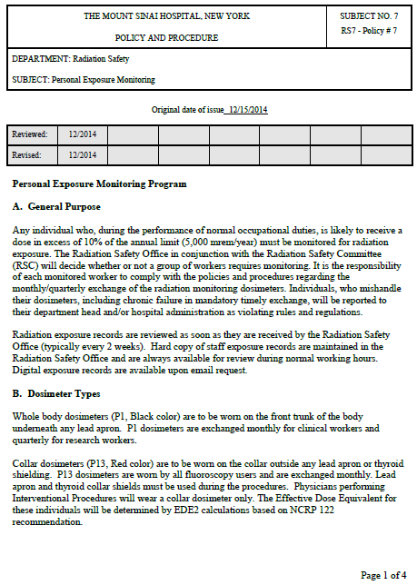

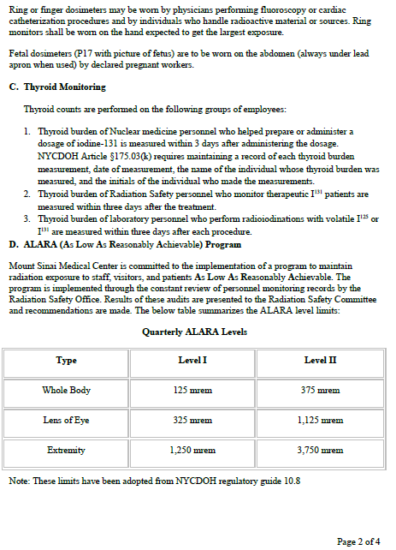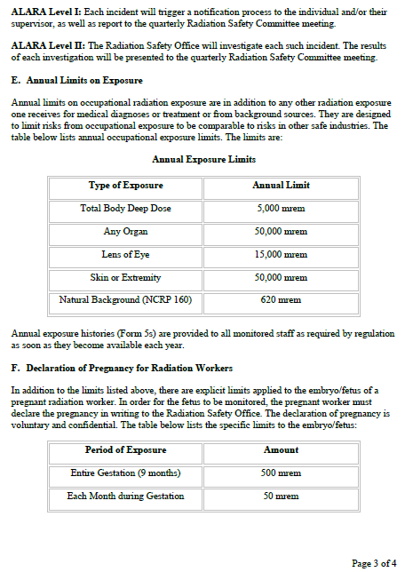
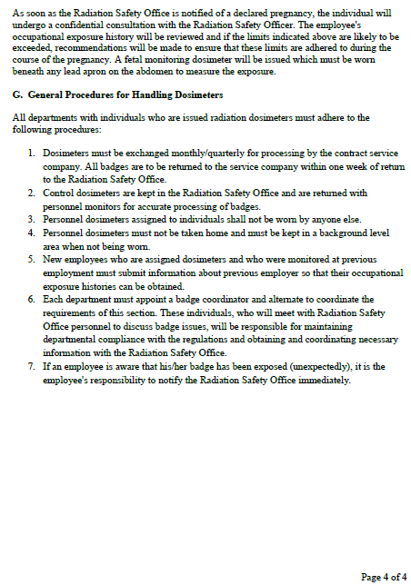

Appendix 2: Monthly Student Intake Form
Months 1-2
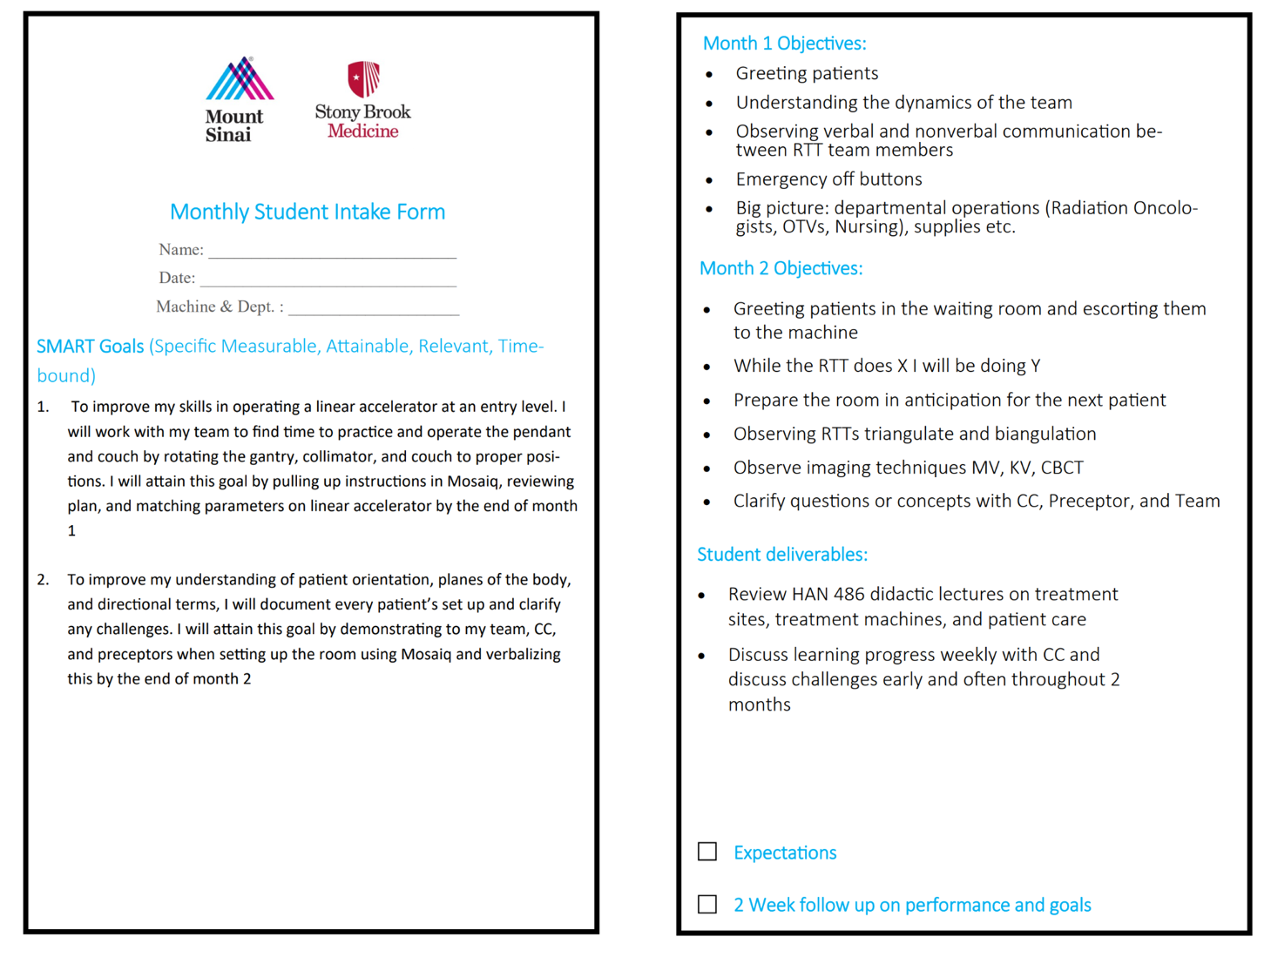

Months 3
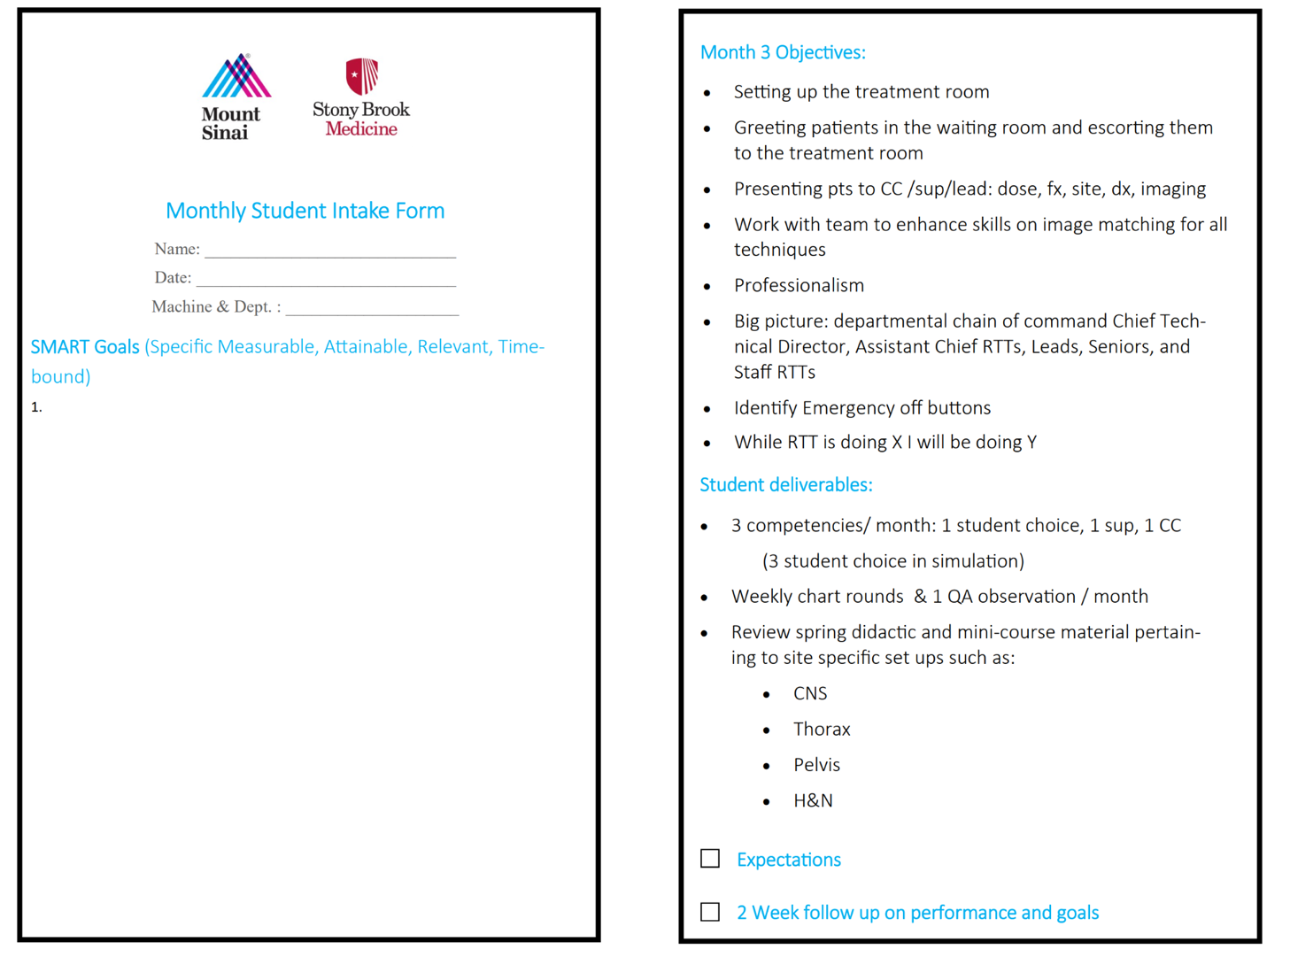

Months 4-7
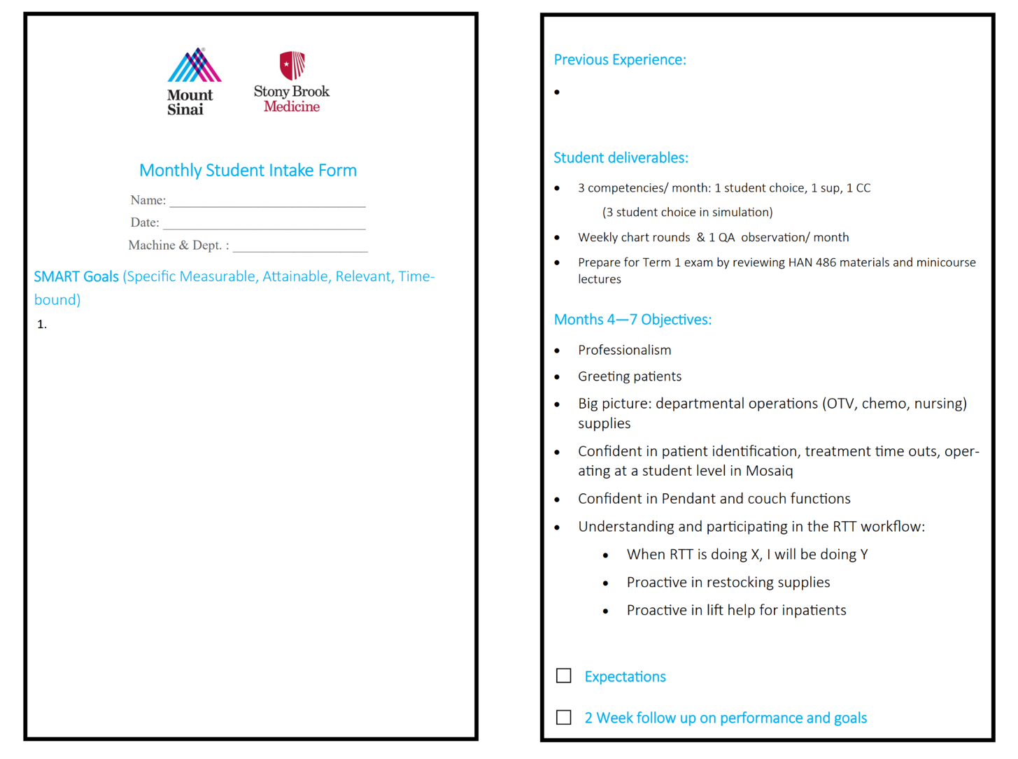

Months 8-12
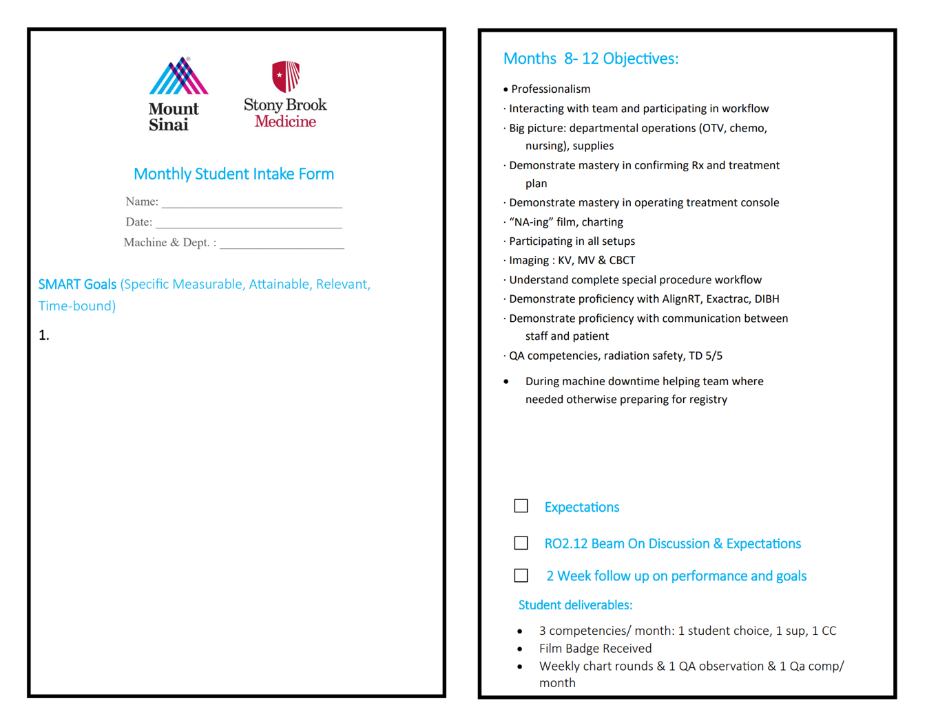
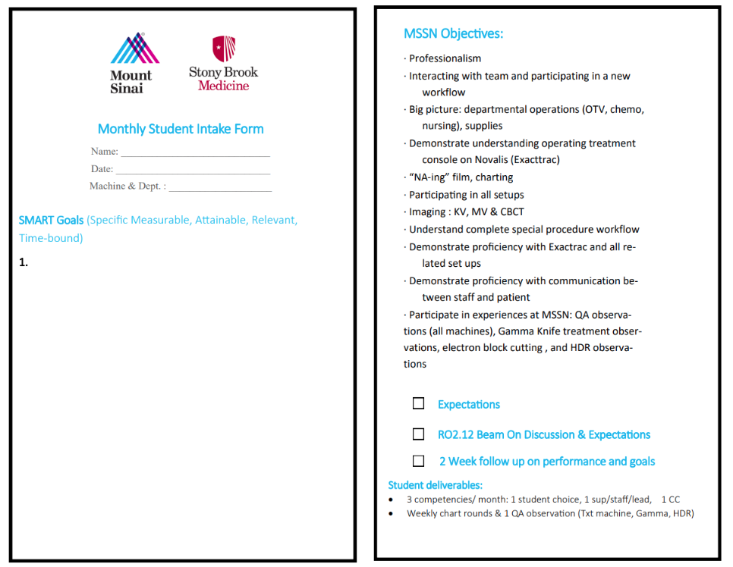

NYPC
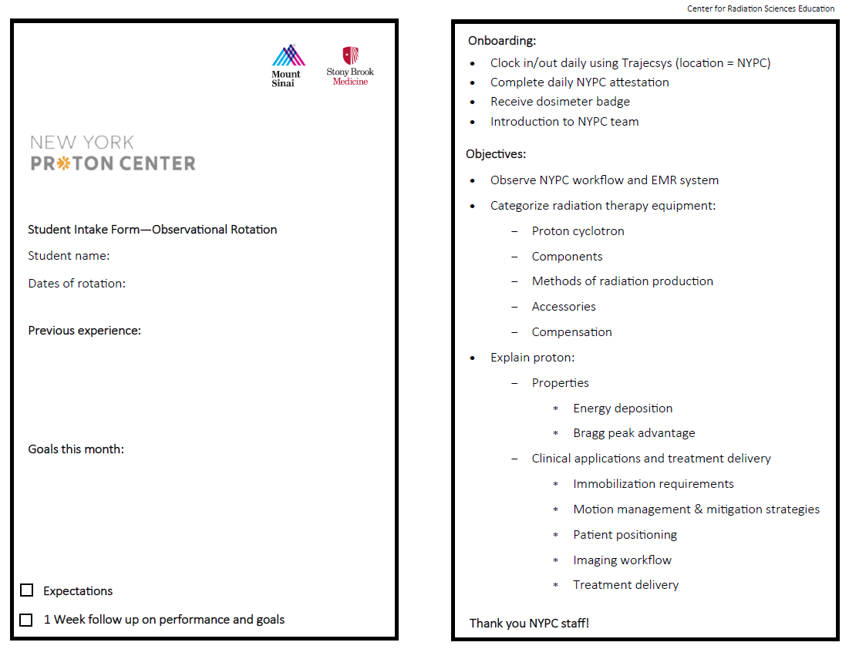

Appendix 3: Monthly Clinical Evaluation – Level I
To be entered via Trajecsys

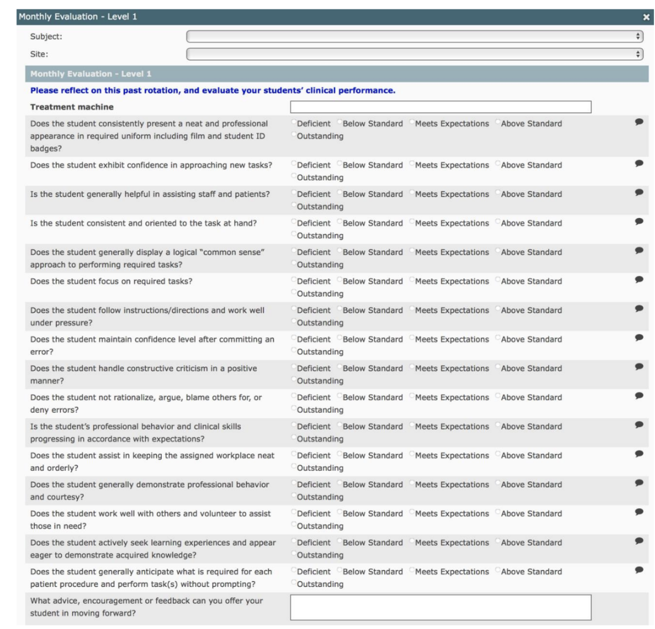

Appendix 4: Monthly Clinical Evaluation – Level II
To be entered via Trajecsys
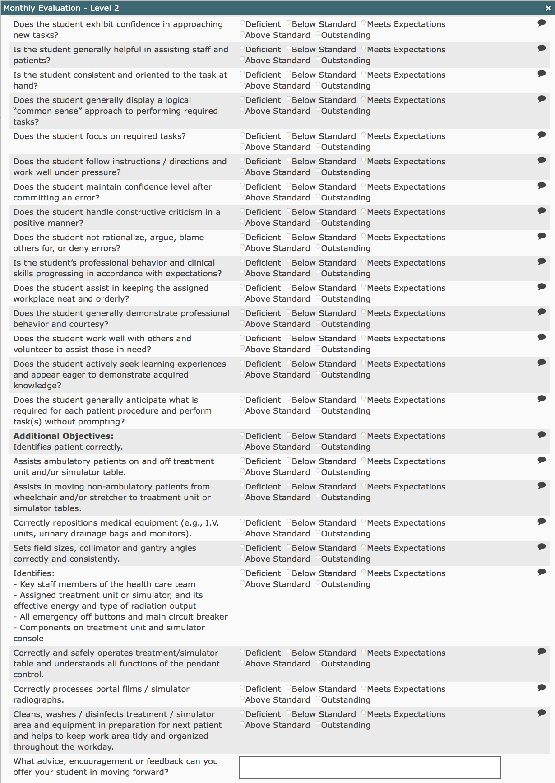

Appendix 5: Mount Sinai Radiation Therapy Student Policy

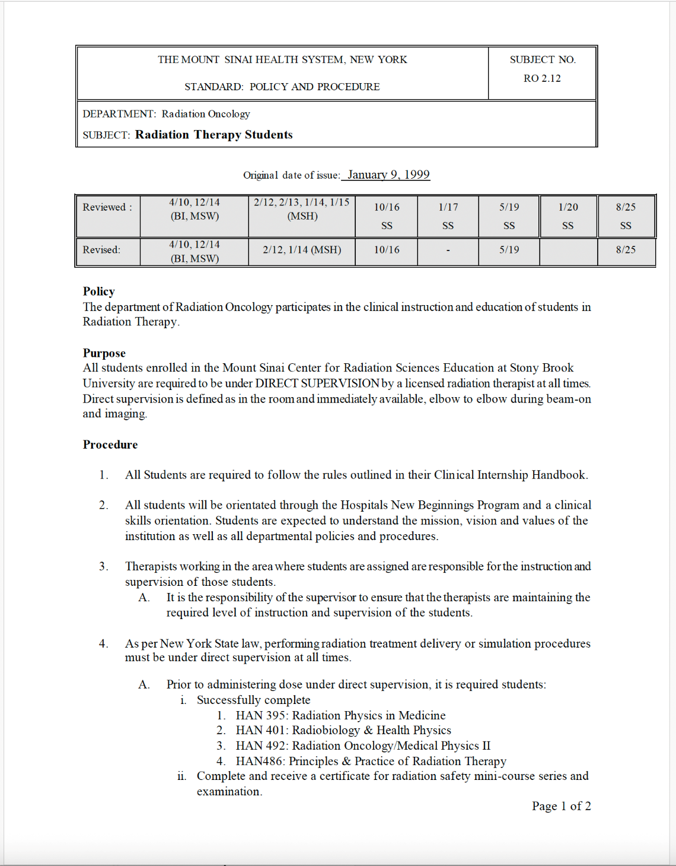
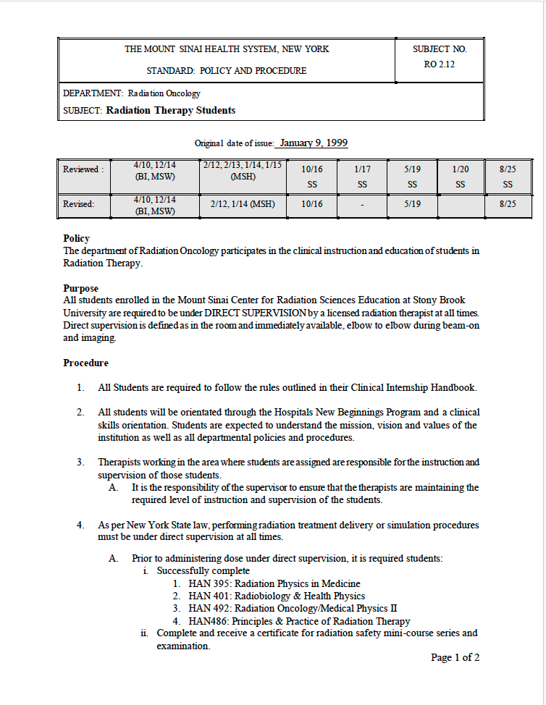
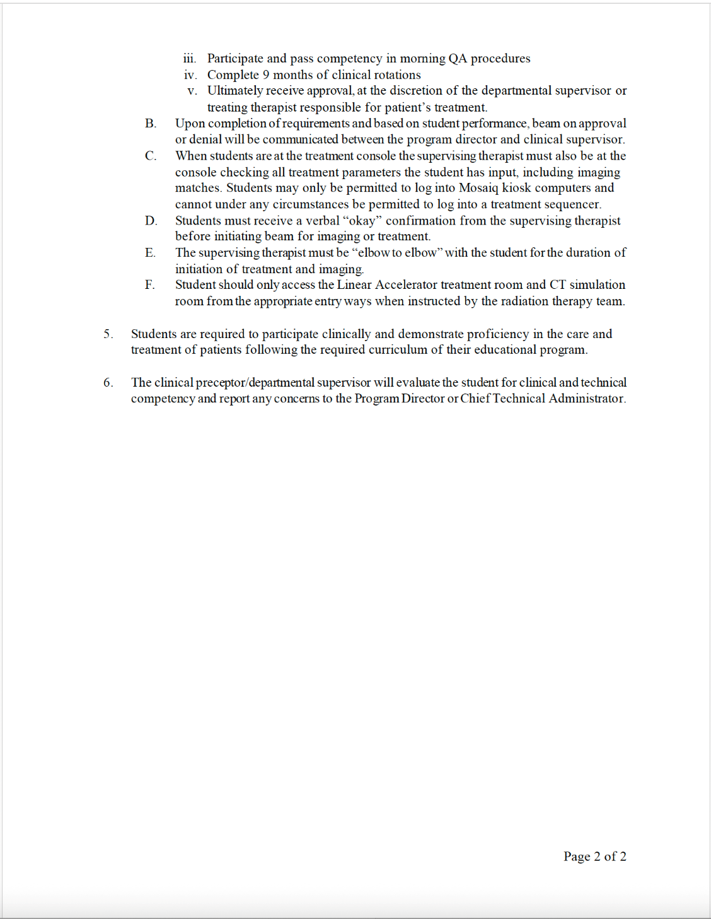

Appendix 6: Clinical Year Locations
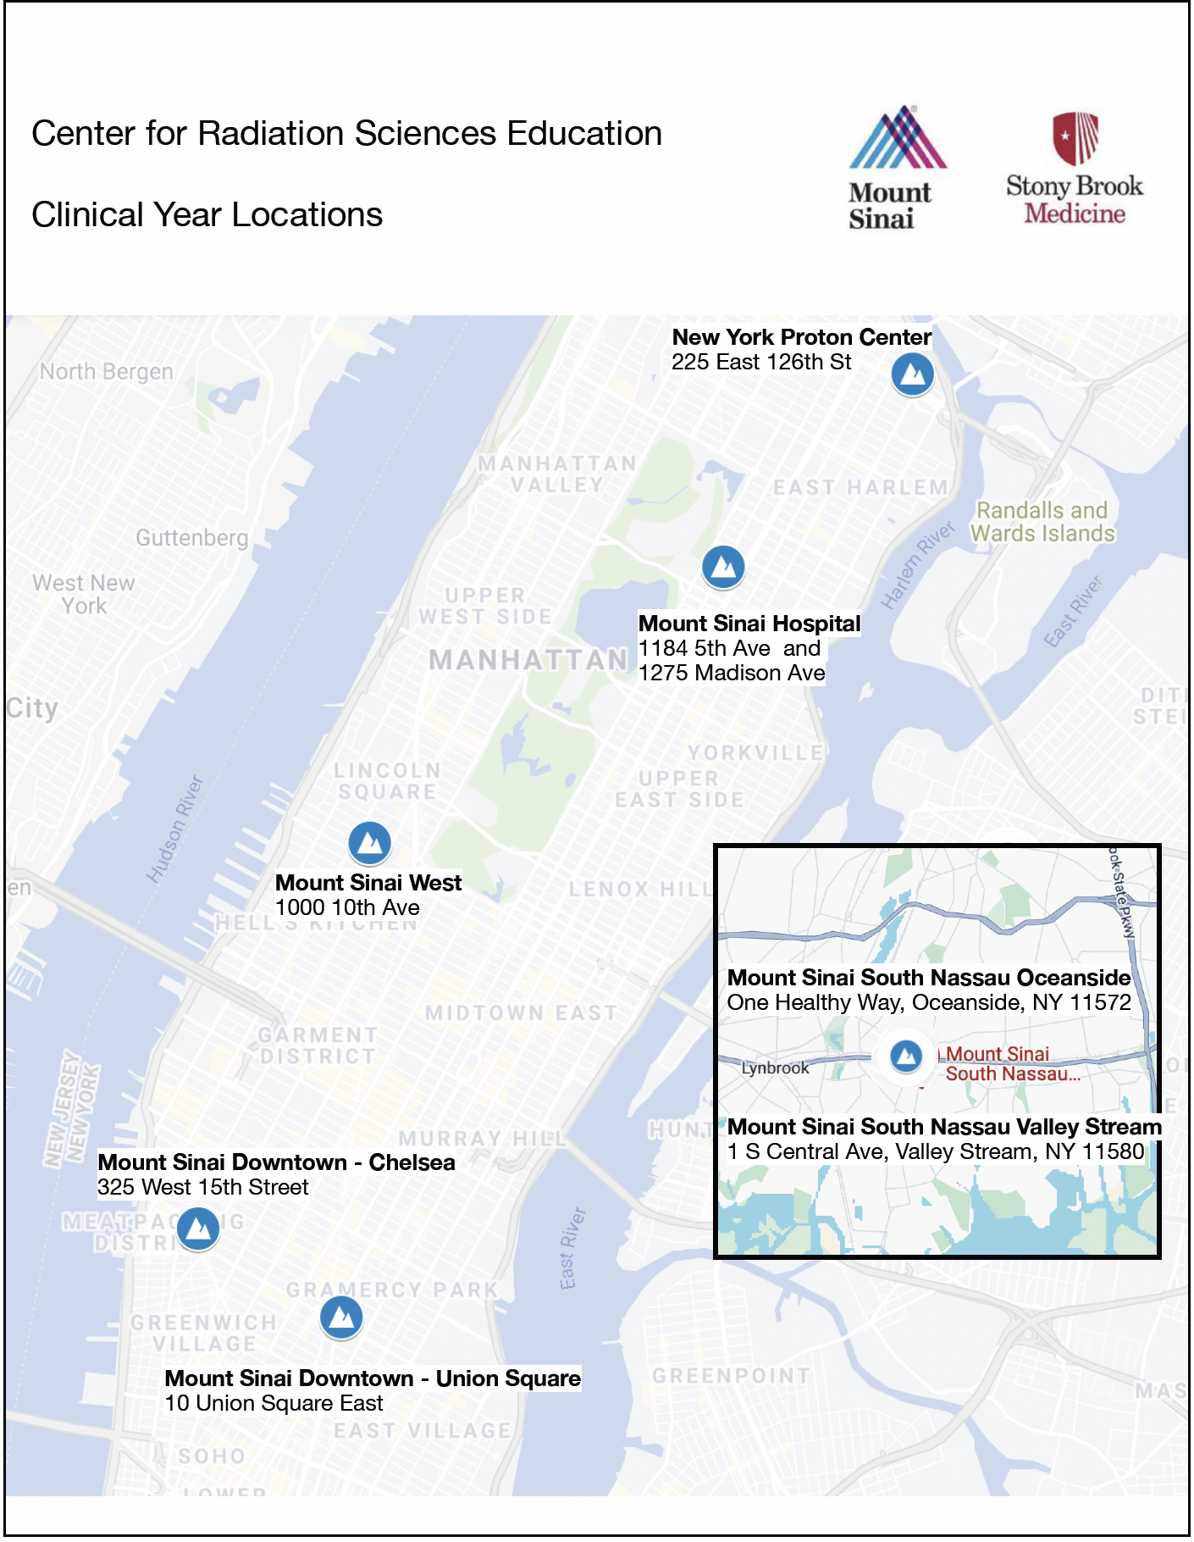

Appendix 7: Morning QA Form
To be entered via Trajecsys
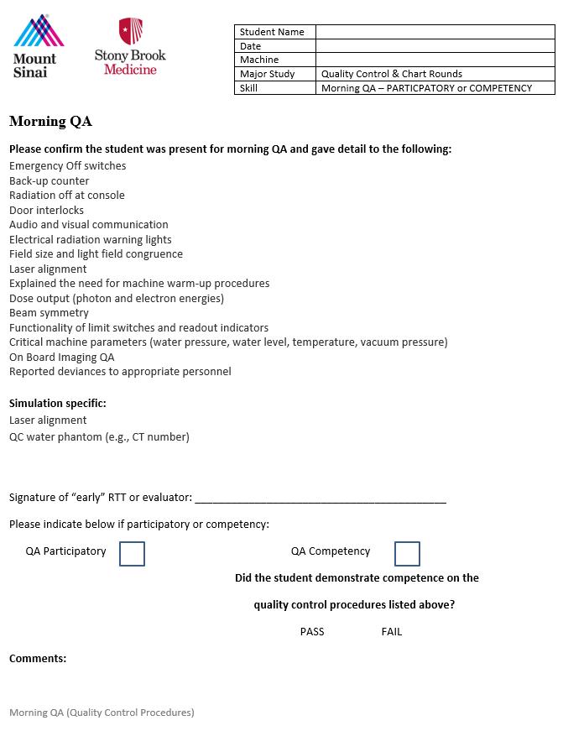

Appendix 8: Grand Rounds Rubric

Appendix 9: Journal Club Presentation Rubrics
Journal Club Mock RTC Rubric
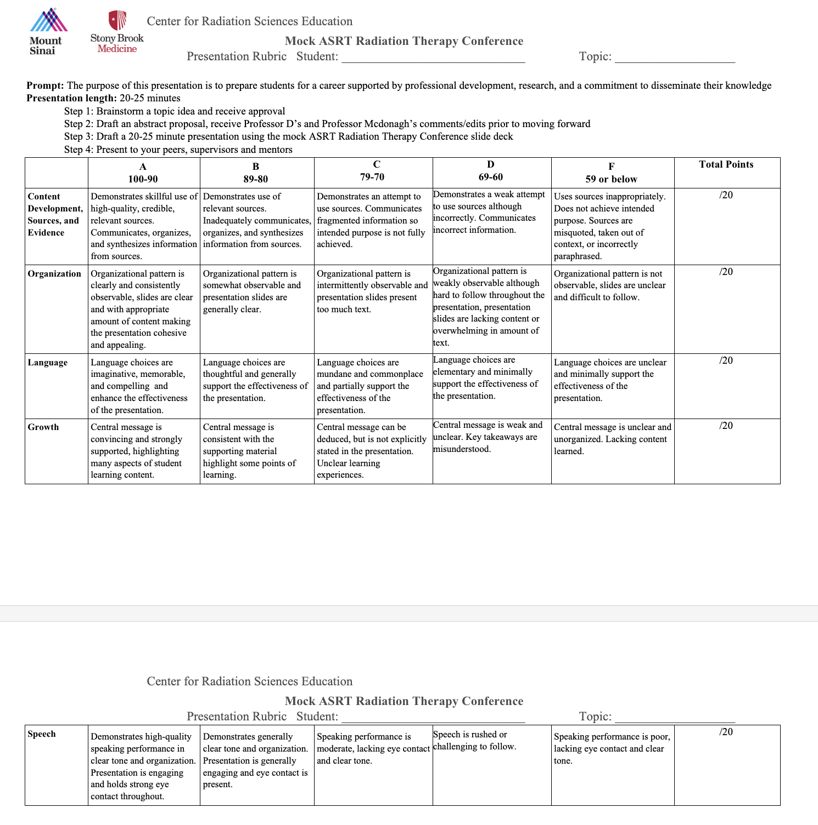

Journal Club RTANYS Essay and Poster
- Students compete each year at the annual Radiation Therapy Association of New York (RTANYS) student competition. Students can submit either an essay, a poster, or both. Prompt will change each year based on the RTANYS education committee’s decision. Students are responsible for printing poster to bring to conference.
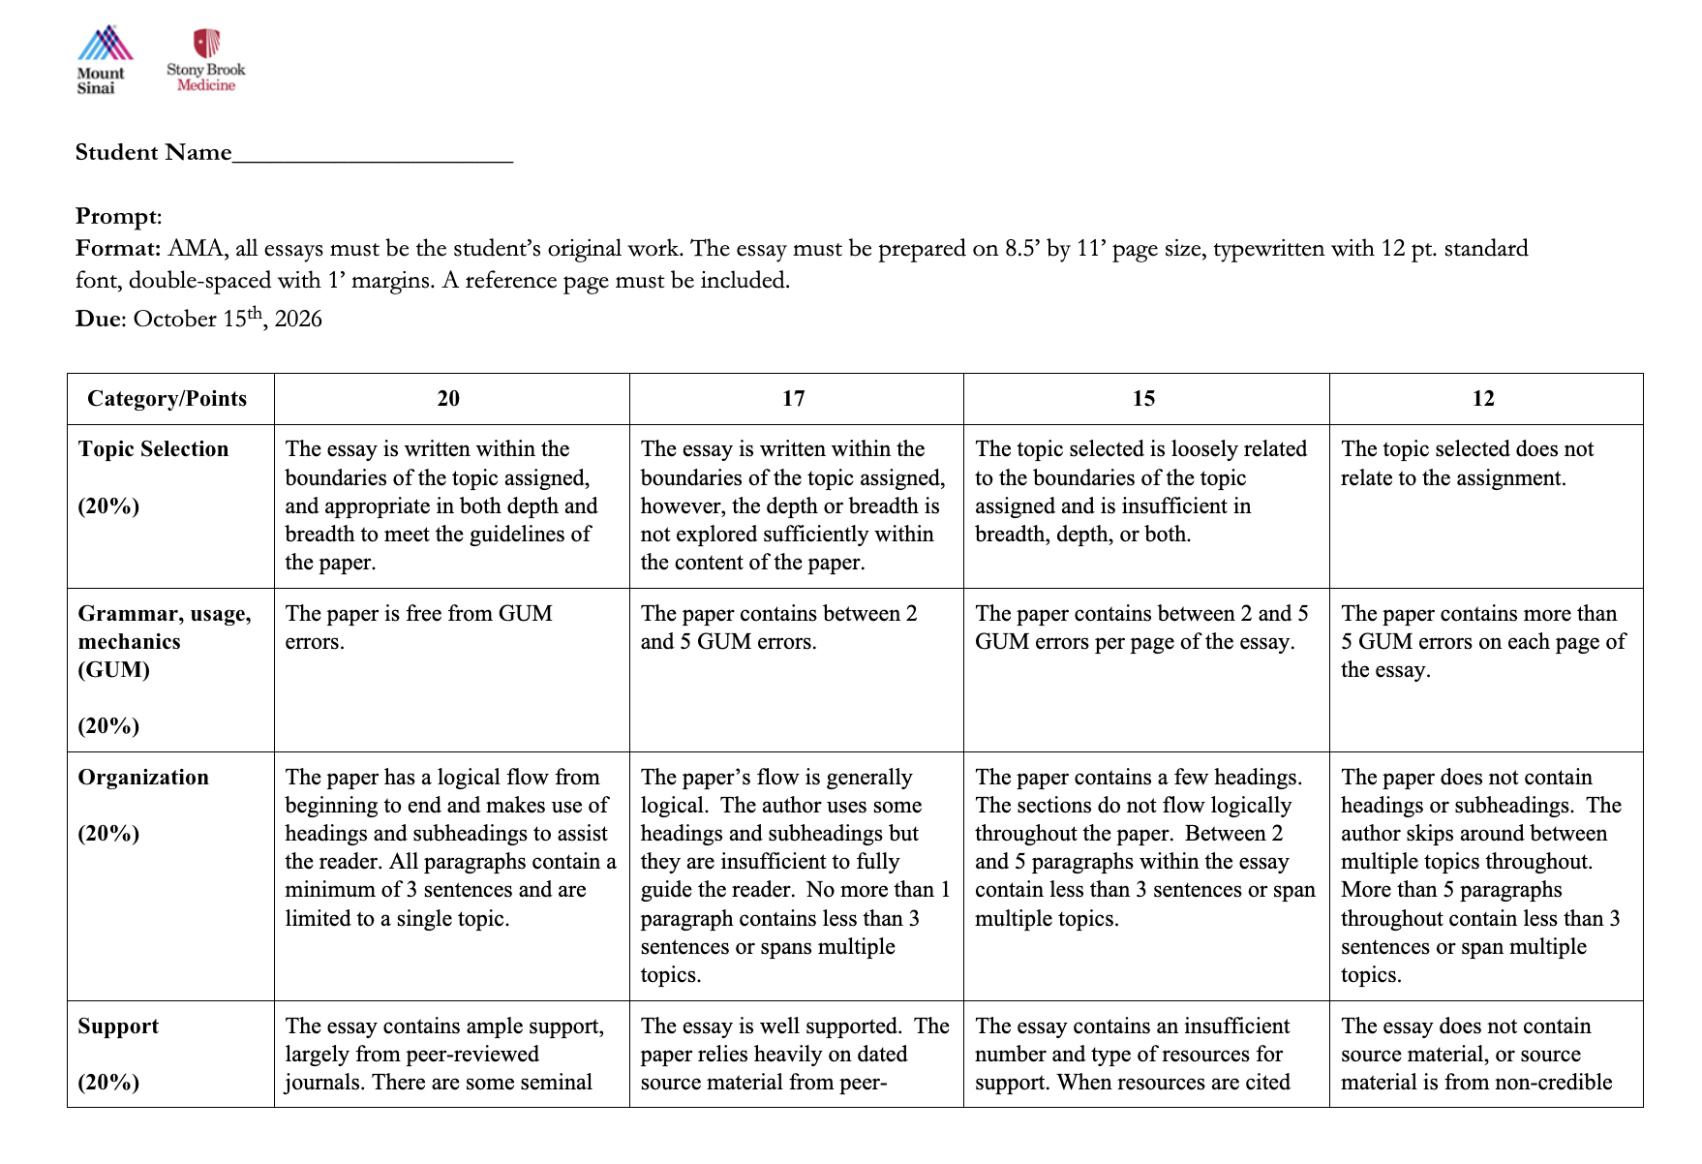
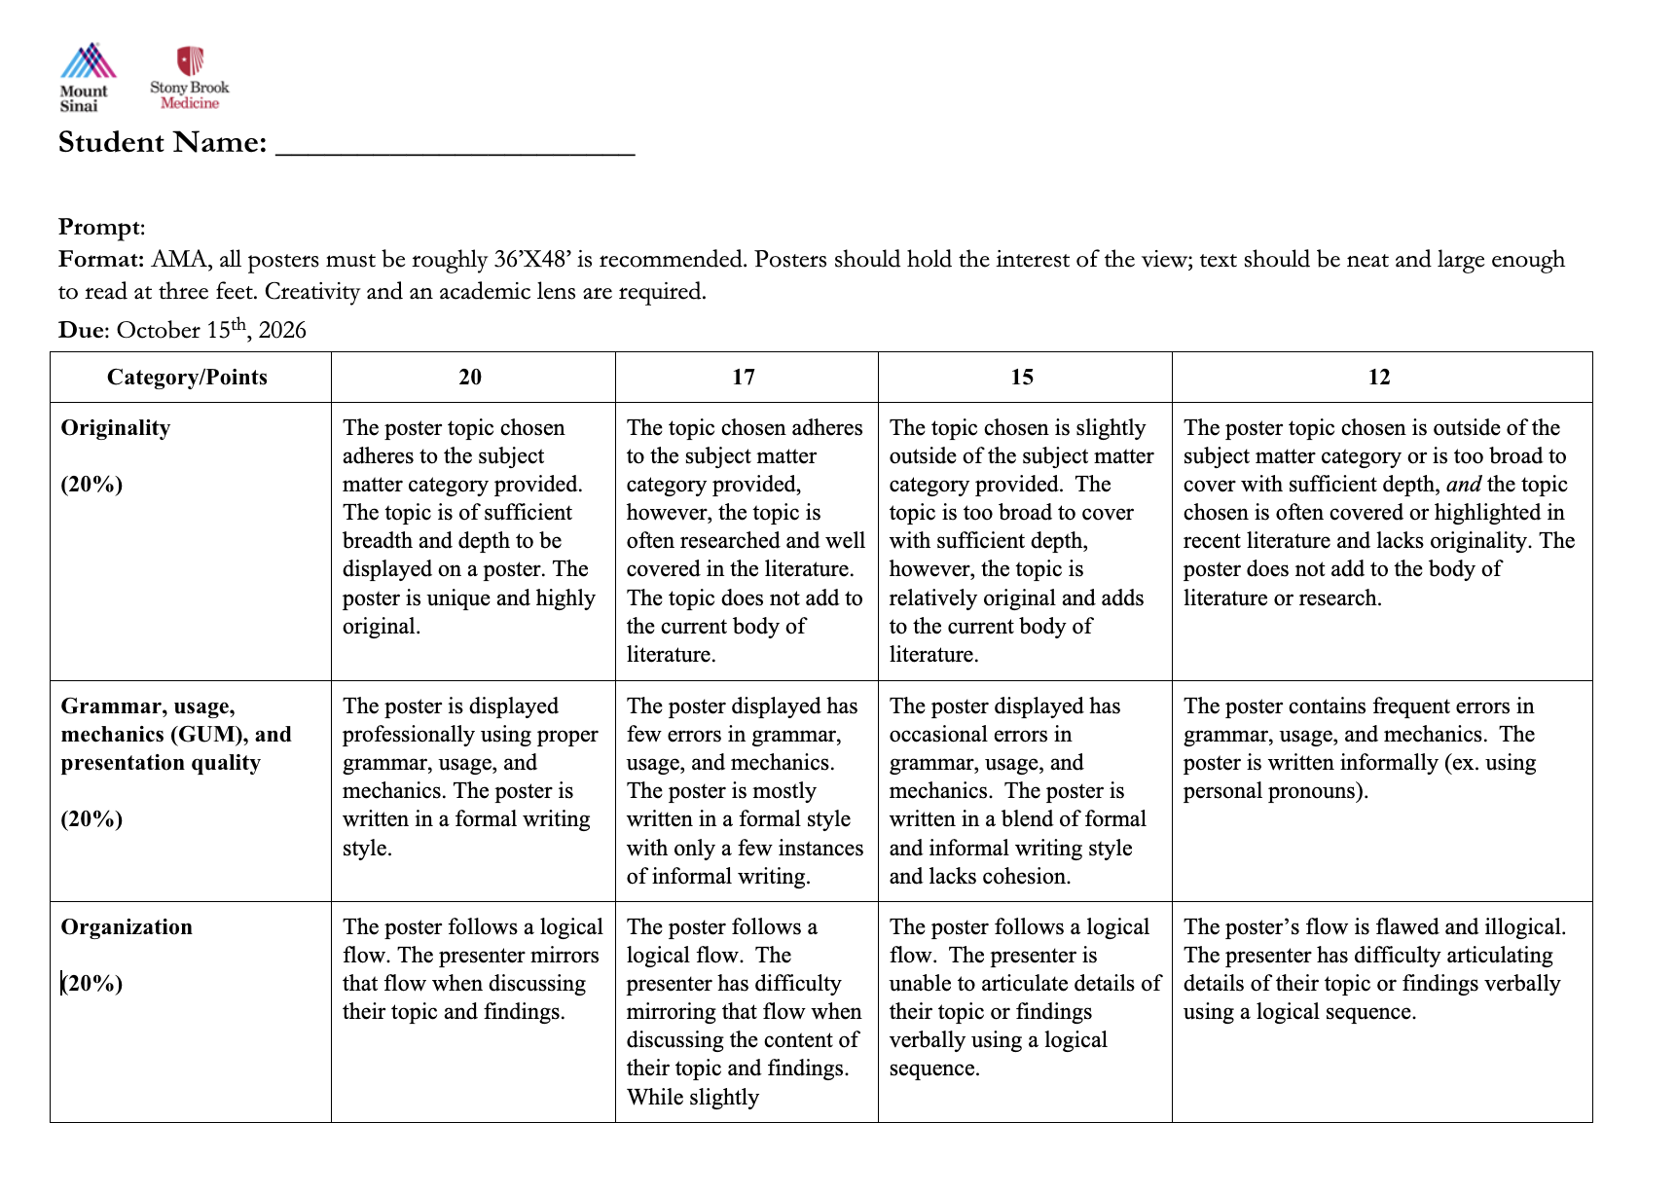
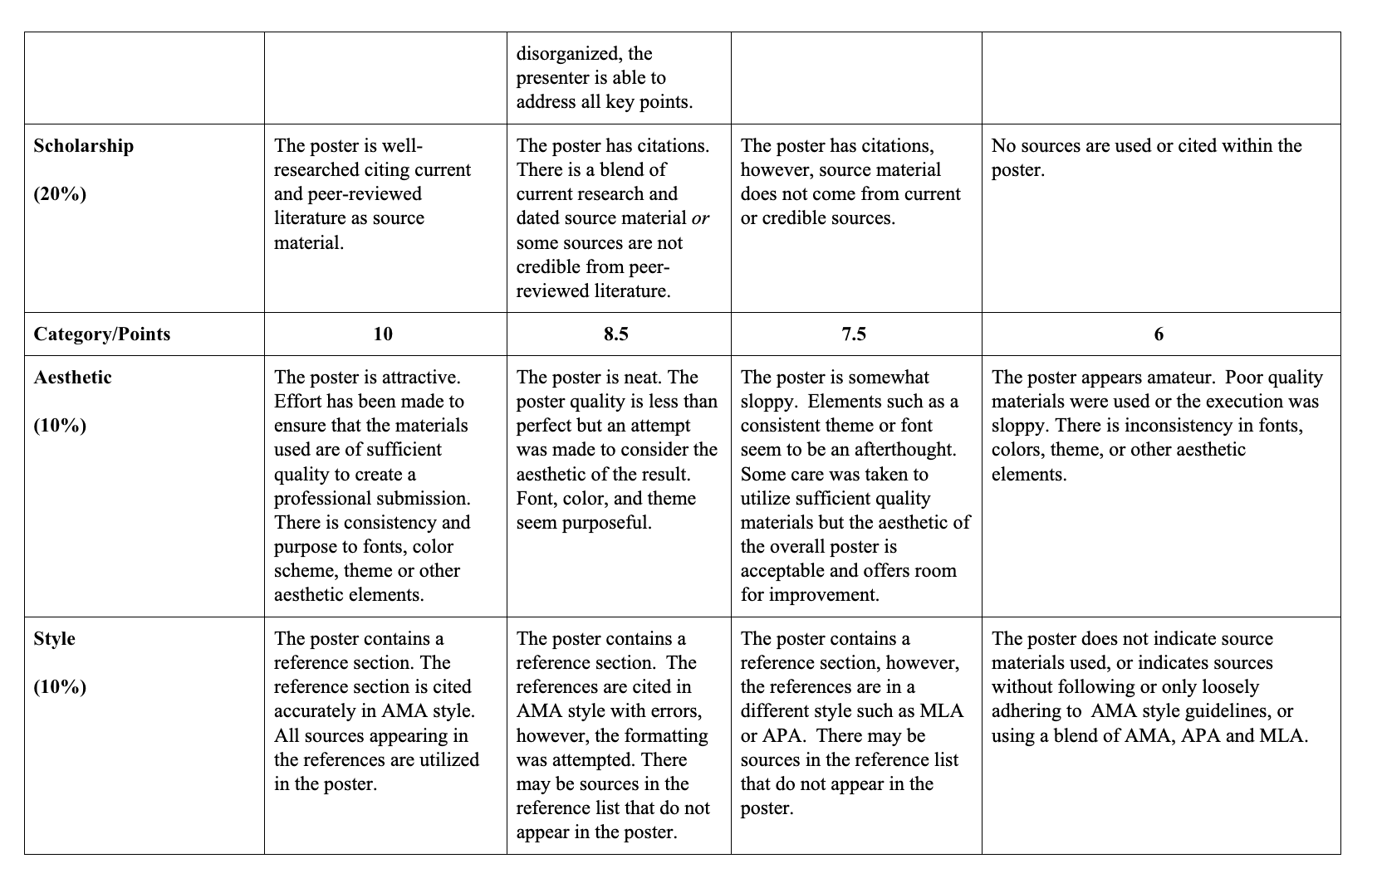

Appendix 10: Required Competencies
Radiation Therapy Treatment Procedures – Competency Objectives (to be submitted via Trajecsys)
Radiation Treatment Procedure | Patient Set-Up | Date | Verified by
 | Or Simulated | Completed | Instructor's Signature
BREAST
Tangents Only
Tangents with Supraclavicular
Tangents with Supraclavicular and Posterior Axilla Boost
Special Set-up (Photon or electron boost, prone, gating)
HEAD AND NECK
Multi Field IMRT
RESPIRATORY/ THORAX
Non-IMRT
IMRT
SBRT**
ABDOMEN
IMRT
SBRT**
PELVIS
Multi-Field Supine
Multi-Field Prone
SBRT**
SKELETAL
Multi-Field Spine
Extremity
HEMATOPOIETIC and LYMPHORETICULAR
Total Body*
CENTRAL NERVOUS SYSTEM
Primary
Metastatic (whole brain)
Craniospinal *
SRT**
SKIN
Primary**
ELECTRON OR PHOTON
Abutting Fields
ELECTRONS
Single Field
*Acceptable to be completed as participatory procedures
** Additional competency required by RTT program

SIMULATION PROCEDURES (to be submitted via Trajecsys)
 | Date Completed | Patient ID# | Instructor(s) Verification
Brain
Breast
Head and Neck
Pelvis
Skeletal
Thorax

Appendix 11: Treatment and Observational Competency Forms
To be entered via Trajecsys 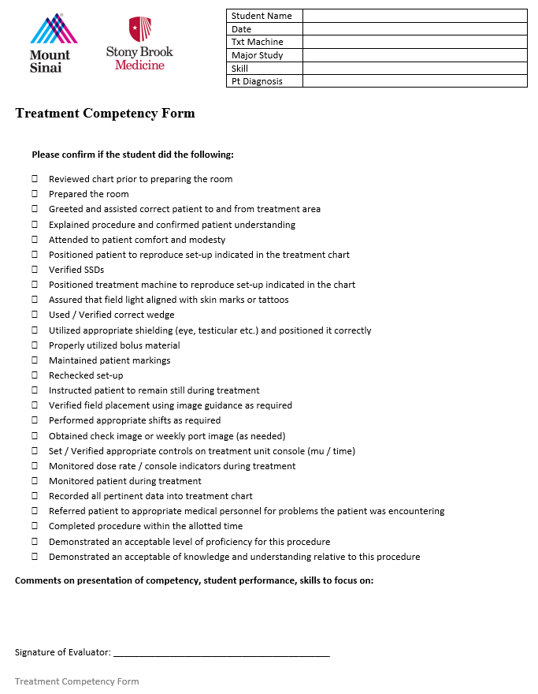

Appendix 12: Simulation Competency Form
To be entered via Trajecsys
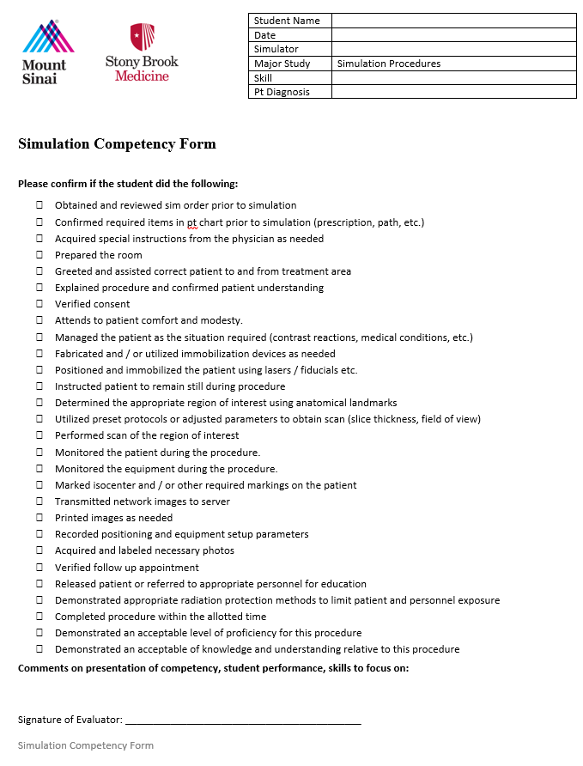
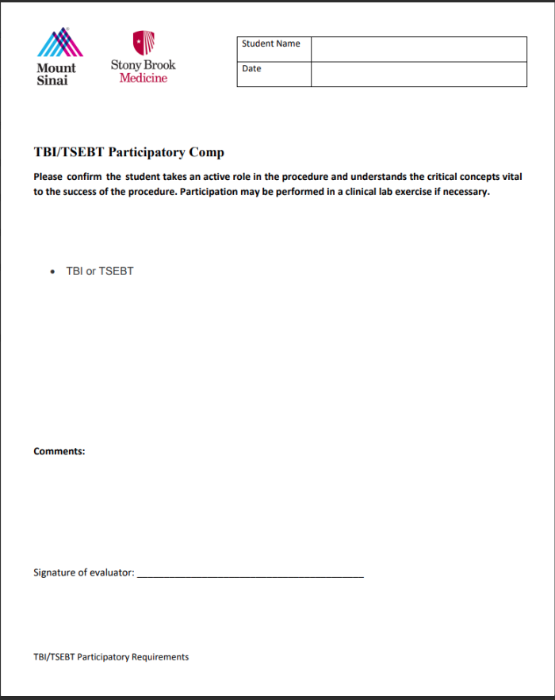

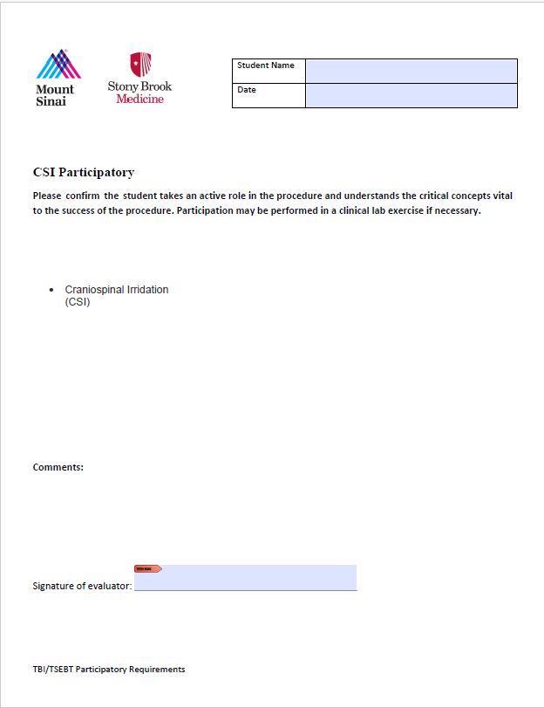

Appendix 13: 2025 Student Orientation handbook School of Health Professions
https://healthprofessions.stonybrookmedicine.edu/programs/hs/about/information/seniors

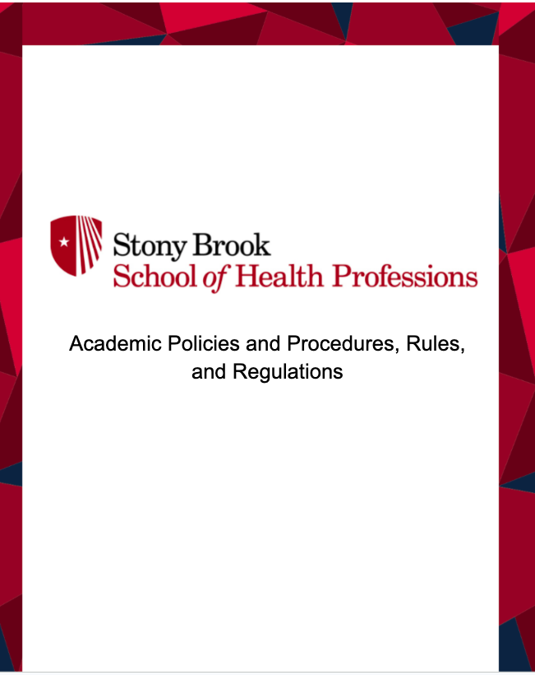

Appendix 14: Mount Sinai Info Sheets
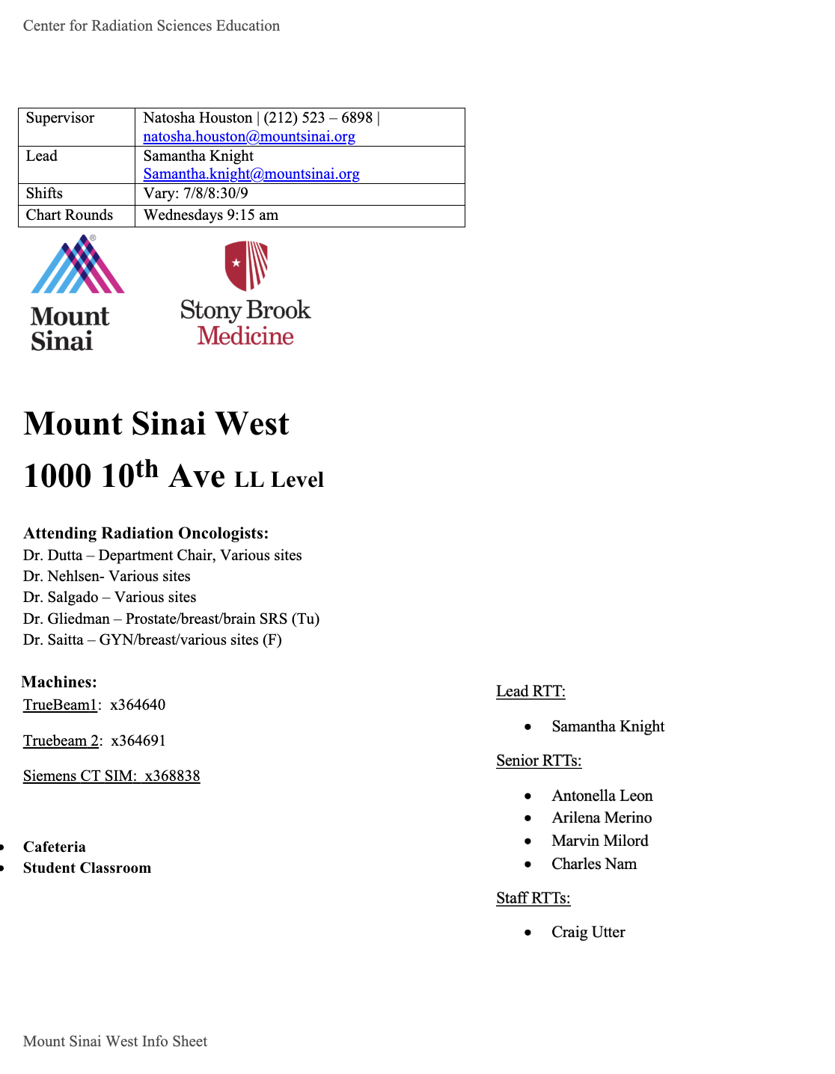

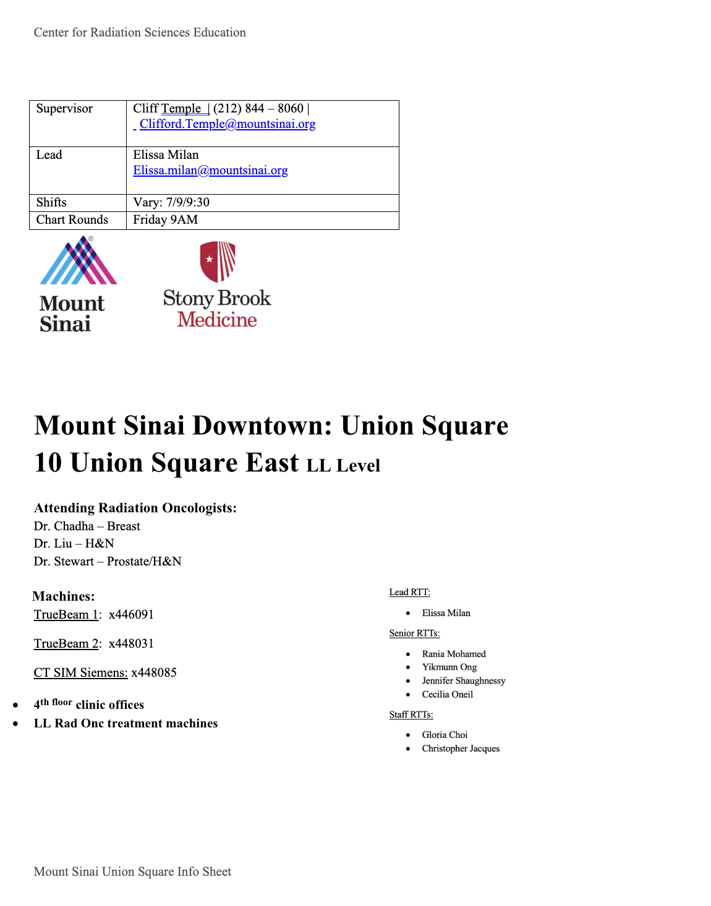

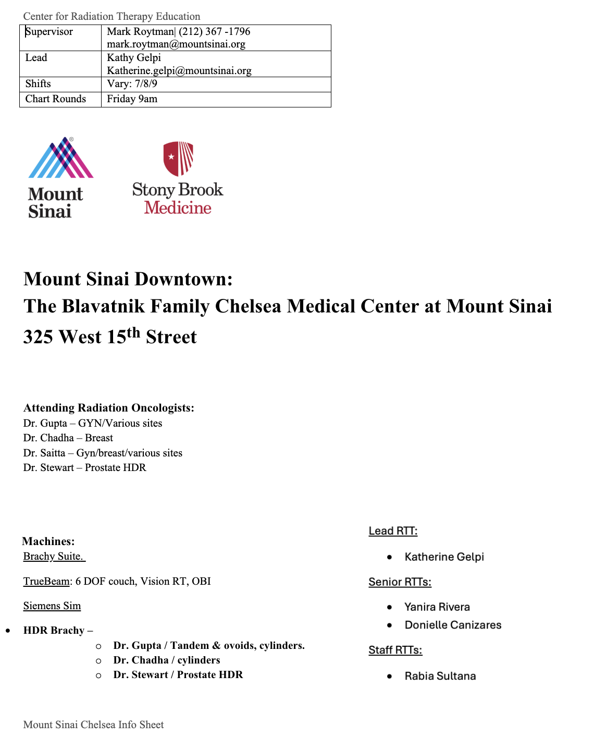

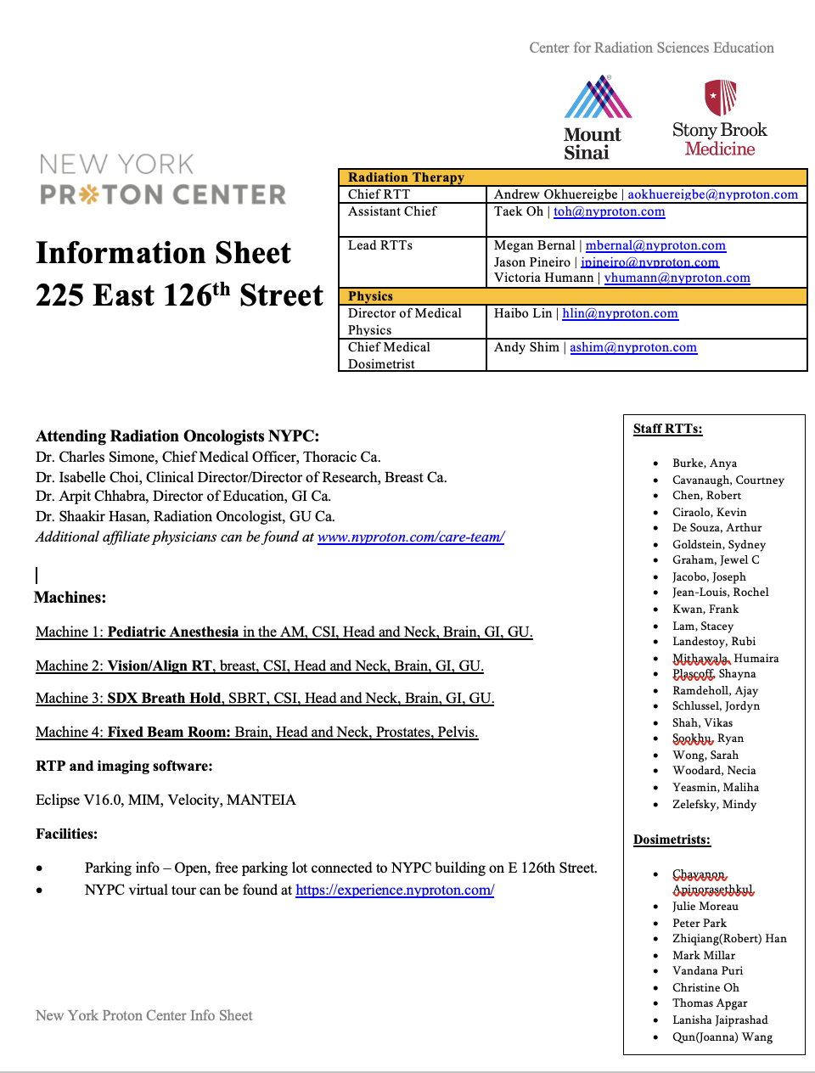

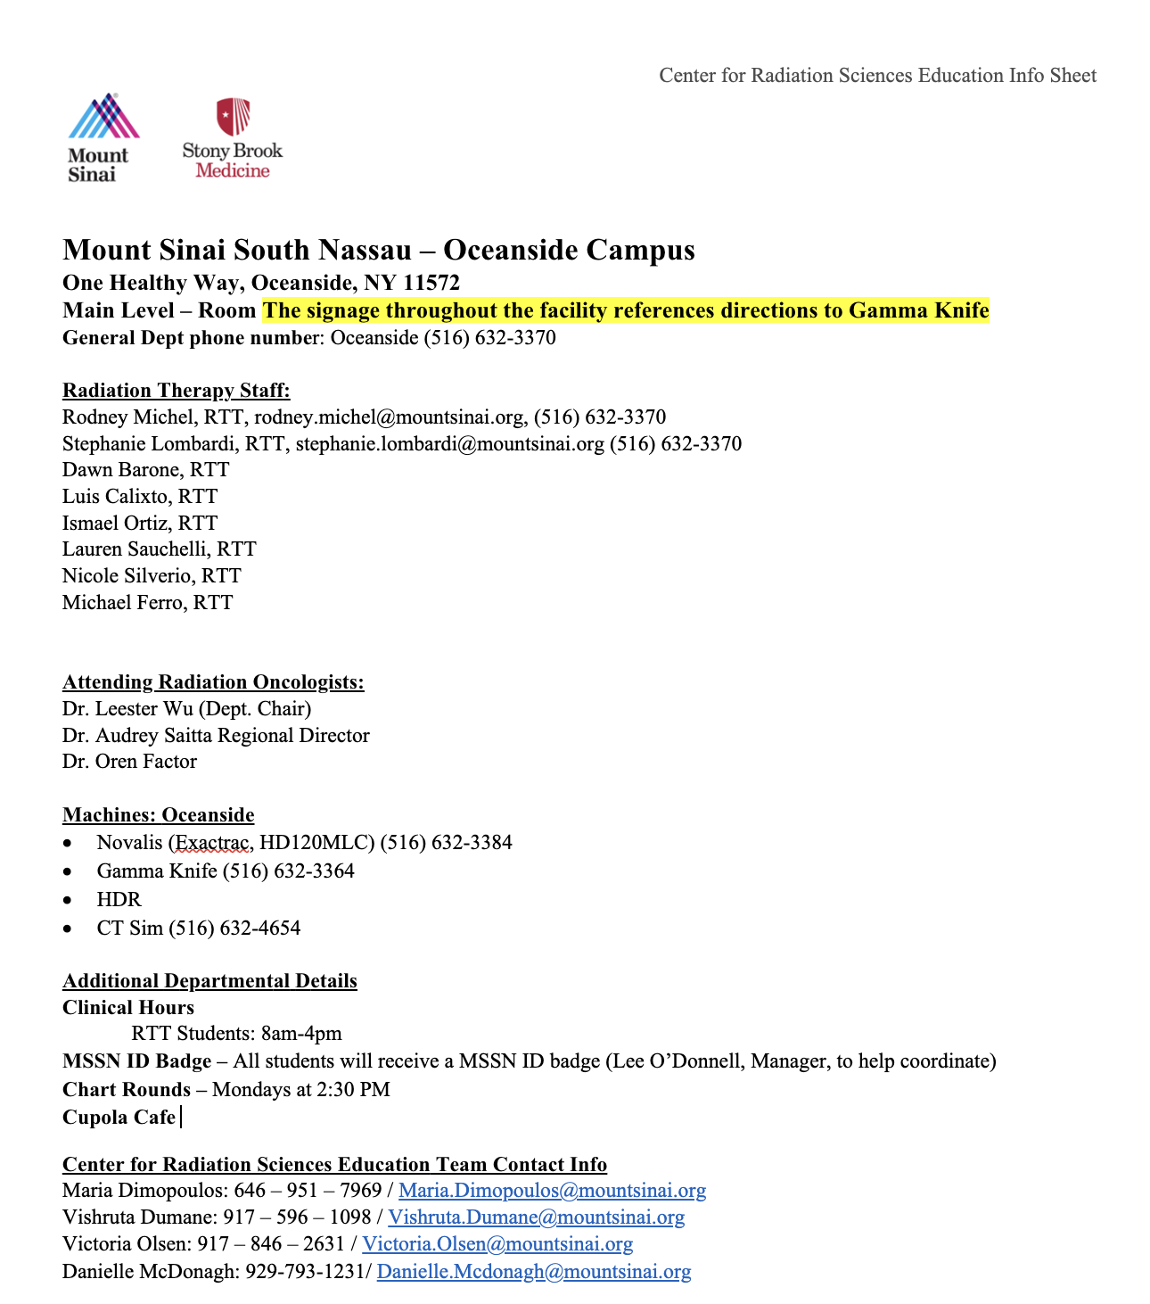

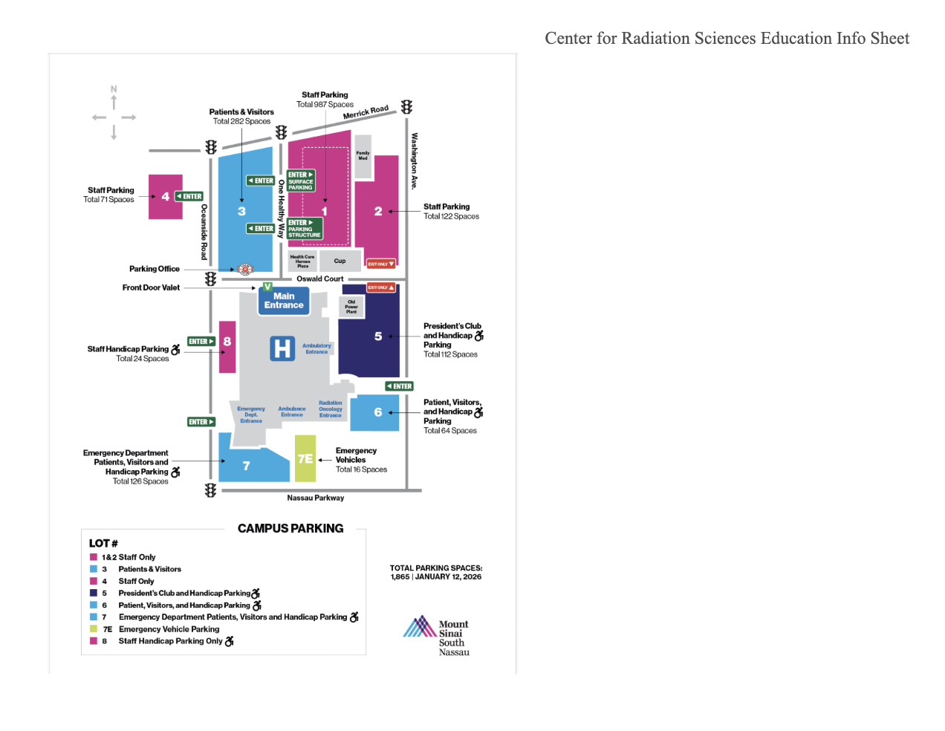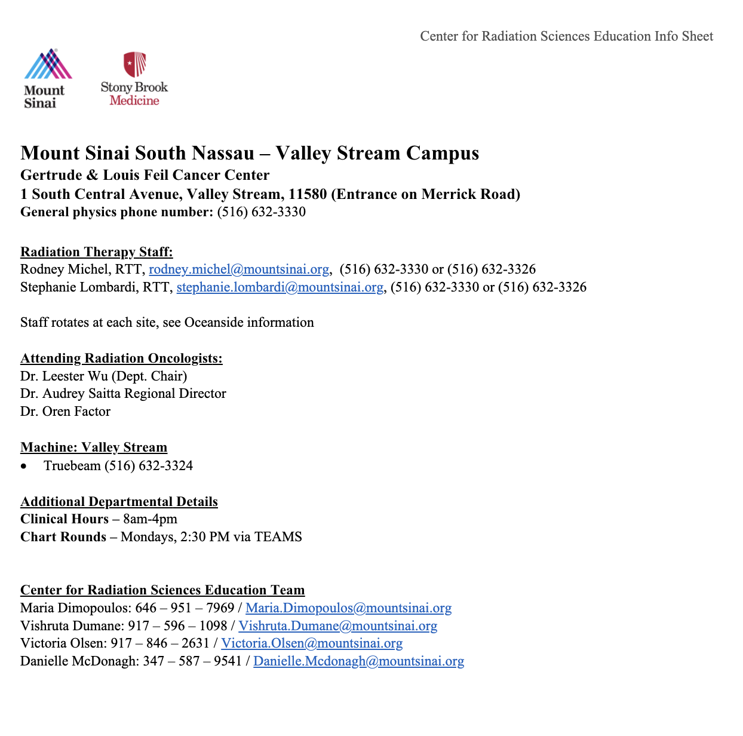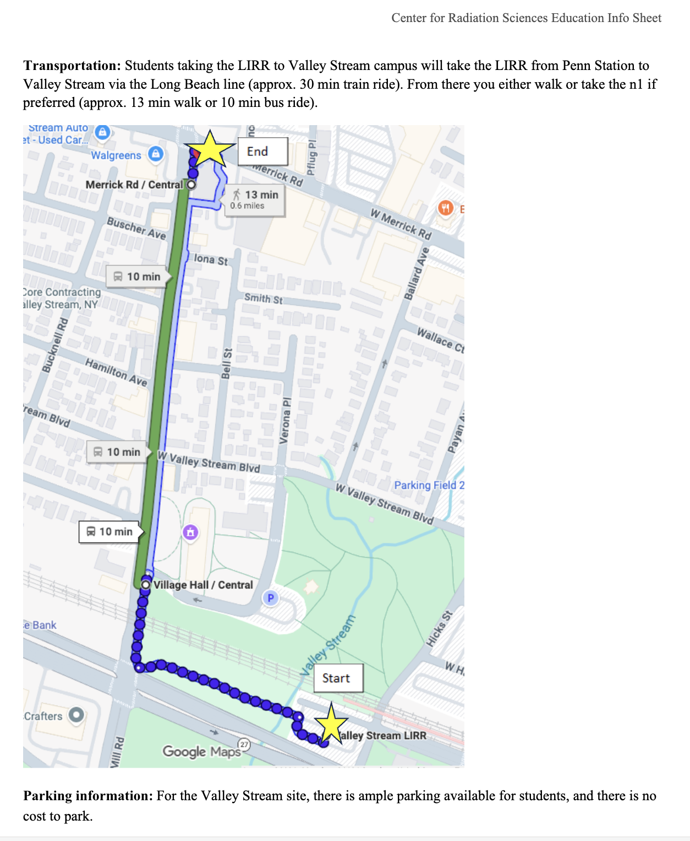

Appendix 15: MRI Training, Protocol and Screening
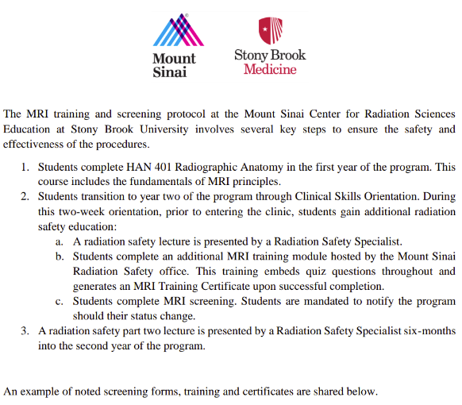

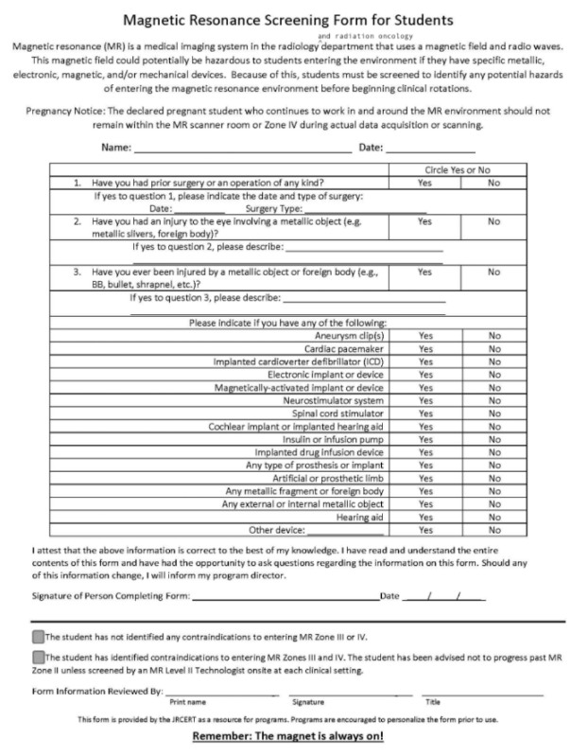
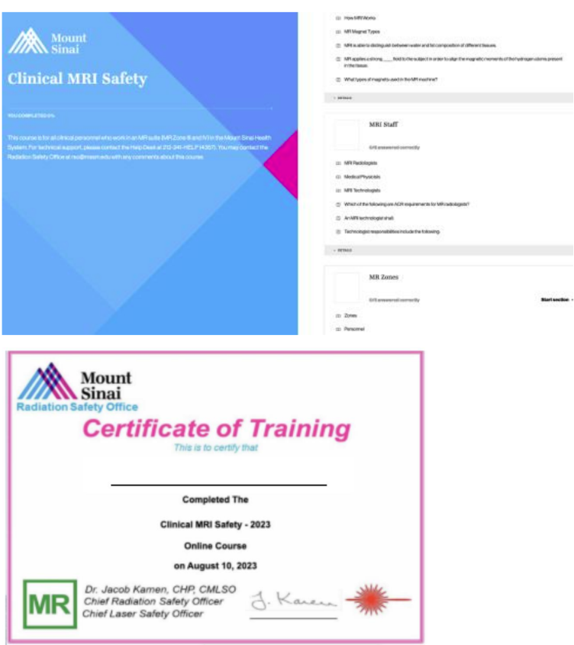

Appendix 16: JRCERT Standards
https://www.jrcert.org/accreditation-information/accreditation-standards-2021/
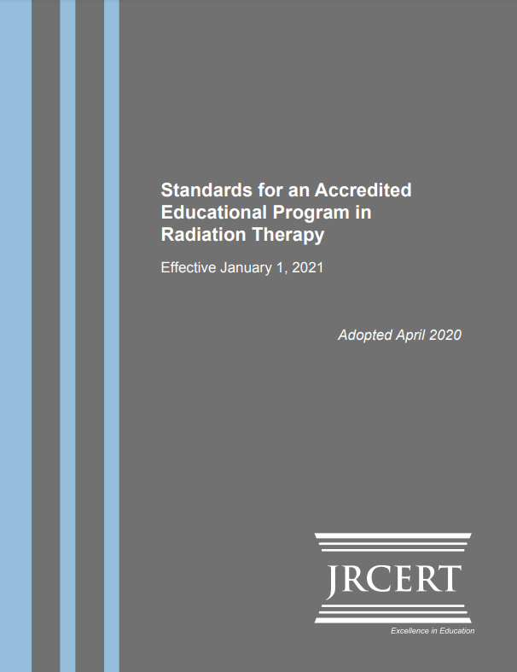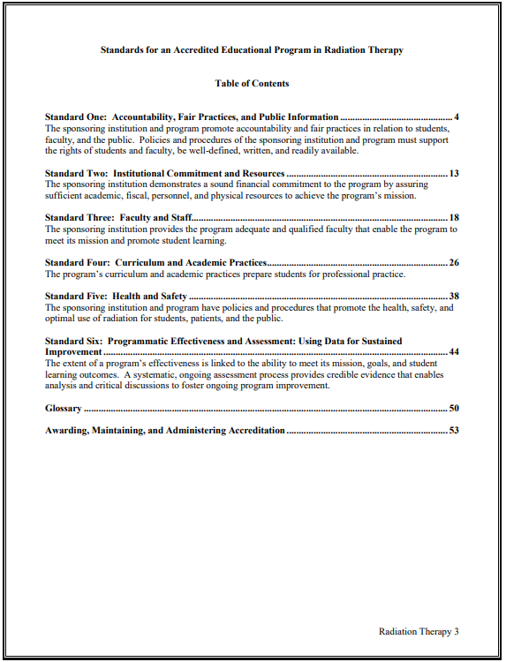

Appendix 16: Nursing Competency Form
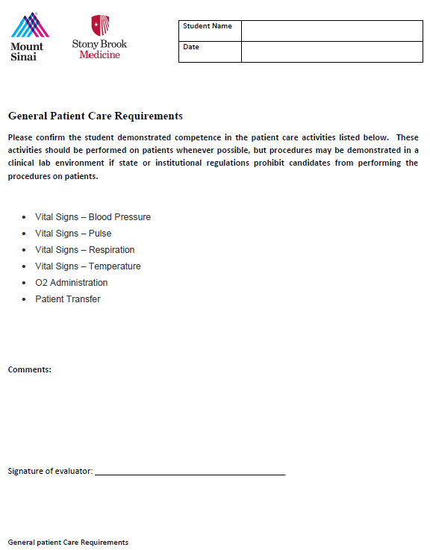

Appendix 17: Dosimetry Competency Form
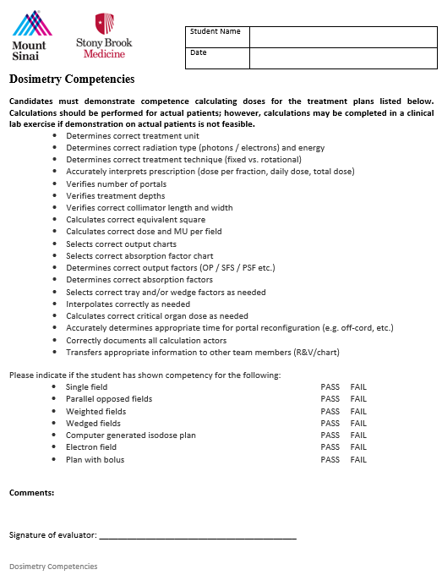

Appendix 18: Brachytherapy Rubric
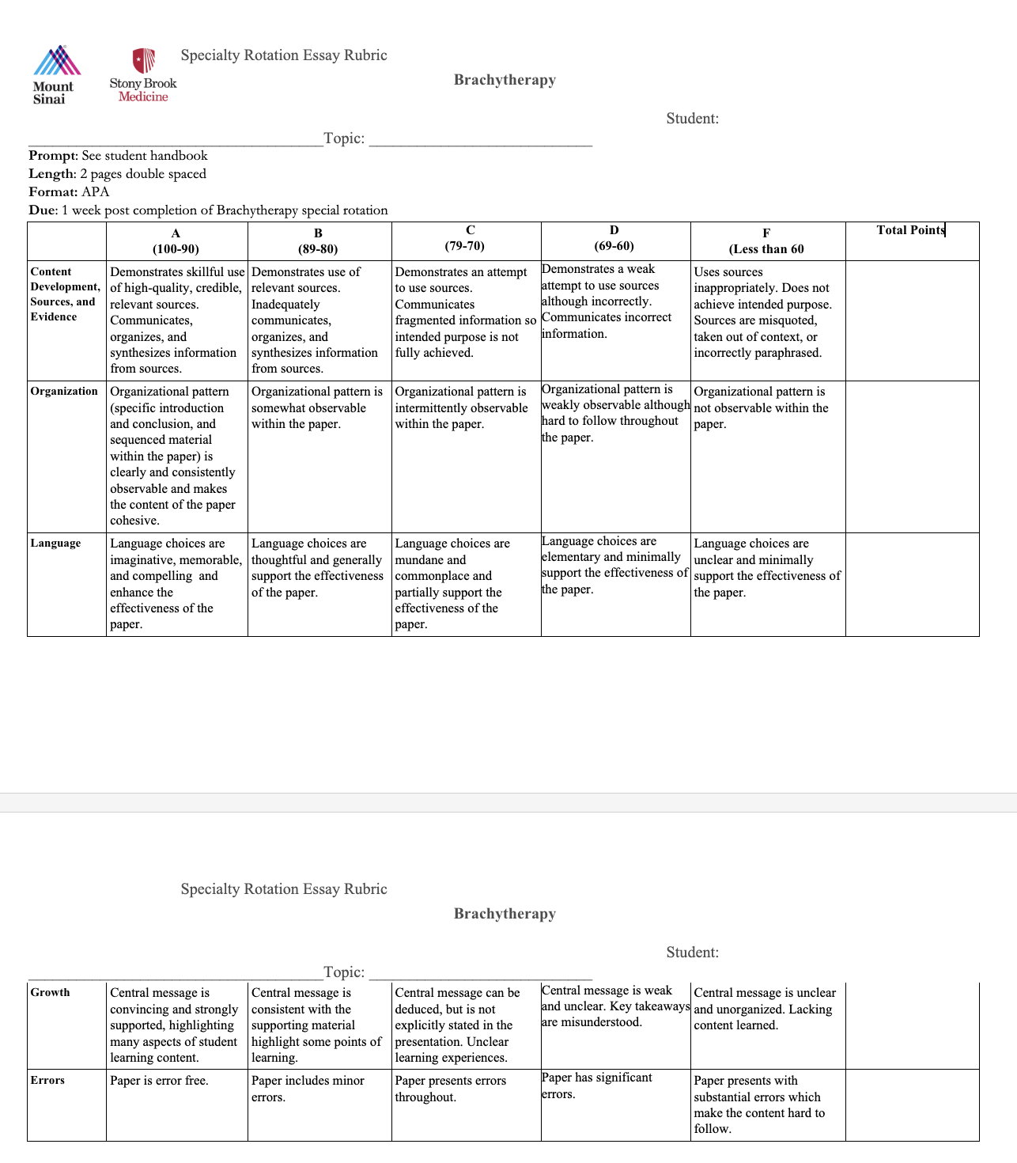

Appendix 19: MD Rotation Rubric
